**CISCO ANSWERED QUESTIONS**

**1. During a routine inspection, a technician discovered that software that was installed on a computer was secretly collecting data about websites that were visited by users of the computer. Which type of threat is affecting this computer?**

* DoS attack​
* identity theft
* **spyware**
* zero-day attack

**2. Which term refers to a network that provides secure access to the corporate offices by suppliers, customers and collaborators?**

* Internet
* intranet
* **extranet**
* extendednet

**3. A large corporation has modified its network to allow users to access network resources from their personal laptops and smart phones. Which networking trend does this describe?**

* cloud computing
* online collaboration
* **bring your own device**
* video conferencing

**4. What is an ISP?**

* It is a standards body that develops cabling and wiring standards for networking.
* It is a protocol that establishes how computers within a local network communicate.
* **It is an organization that enables individuals and businesses to connect to the Internet.**
* It is a networking device that combines the functionality of several different networking devices in one.

**5. Match the requirements of a reliable network with the supporting network architecture. (Not all options are used.)**  
[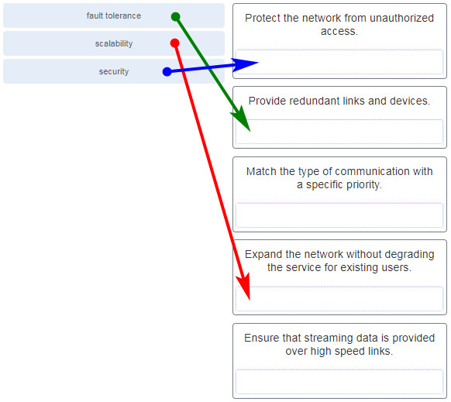](https://itexamanswers.net/wp-content/uploads/2019/12/2020-03-08_181549.jpg)

**6. An employee at a branch office is creating a quote for a customer. In order to do this, the employee needs to access confidential pricing information from internal servers at the Head Office. What type of network would the employee access?**

* **an intranet**
* the Internet
* an extranet
* a local area network

**Explanation:** Intranet is a term used to refer to a private connection of LANs and WANs that belongs to an organization. An intranet is designed to be accessible only by the organization’s members, employees, or others with authorization.

**7. Which statement describes the use of powerline networking technology?**

* New “smart” electrical cabling is used to extend an existing home LAN.
* A home LAN is installed without the use of physical cabling.
* **A device connects to an existing home LAN using an adapter and an existing electrical outlet.**
* Wireless access points use powerline adapters to distribute data through the home LAN.

**8. A networking technician is working on the wireless network at a medical clinic. The technician accidentally sets up the wireless network so that patients can see the medical records data of other patients. Which of the four network characteristics has been violated in this situation?**

* fault tolerance
* scalability
* **security**
* Quality of Service (QoS)
* reliability

**Explanation:** Network security includes protecting the confidentiality of data that is on the network. In this case, because confidential data has been made available to unauthorized users, the security characteristic of the network has failed.

**9. Match each characteristic to its corresponding Internet connectivity type. (Not all options are used.)**  
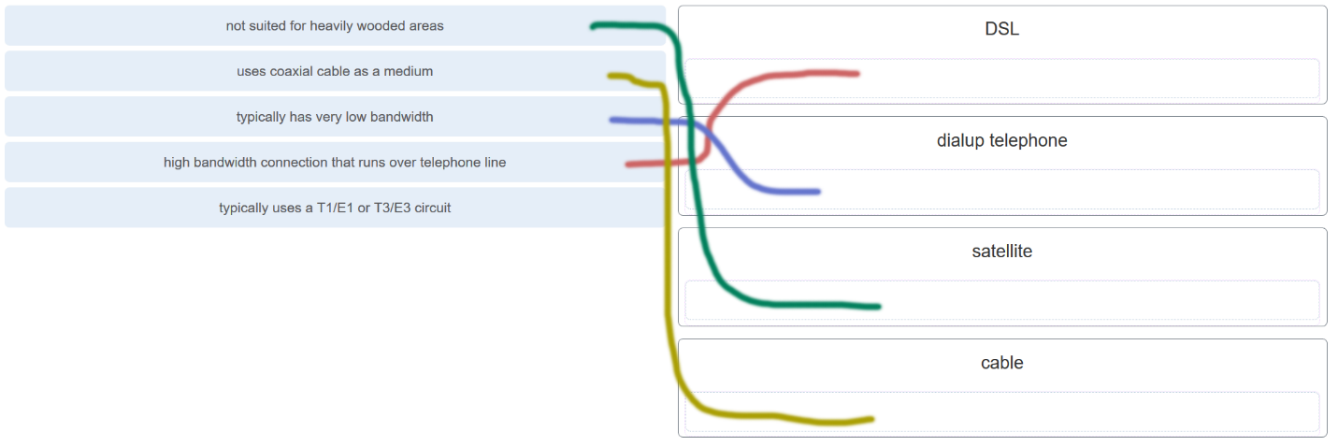

**Explanation:** DSL is an always-on, high bandwidth connection that runs over telephone lines. Cable uses the same coaxial cable that carries television signals into the home to provide Internet access. Dialup telephone is much slower than either DSL or cable, but is the least expensive option for home users because it can use any telephone line and a simple modem. Satellite requires a clear line of sight and is affected by trees and other obstructions. None of these typical home options use dedicated leased lines such as T1/E1 and T3/E3.

**10. What two criteria are used to help select a network medium from various network media? (Choose two.)**

* the types of data that need to be prioritized
* the cost of the end devices utilized in the network
* **the distance the selected medium can successfully carry a signal**
* the number of intermediate devices installed in the network
* **the environment where the selected medium is to be installed**

**Explanation:** Criteria for choosing a network medium are the distance the selected medium can successfully carry a signal, the environment in which the selected medium is to be installed, the amount of data and the speed at which the data must be transmitted, and the cost of the medium and its installation.

**11. What type of network traffic requires QoS?**

* email
* on-line purchasing
* **video conferencing**
* wiki

**12. A user is implementing security on a small office network. Which two actions would provide the minimum security requirements for this network? (Choose two.)**

* **implementing a firewall**
* installing a wireless network
* **installing antivirus software**
* implementing an intrusion detection system
* adding a dedicated intrusion prevention device

**Explanation:** Technically complex security measures such as intrusion prevention and intrusion prevention systems are usually associated with business networks rather than home networks. Installing antivirus software, antimalware software, and implementing a firewall will usually be the minimum requirements for home networks. Installing a home wireless network will not improve network security, and will require further security actions to be taken.

**13. Passwords can be used to restrict access to all or parts of the Cisco IOS. Select the modes and interfaces that can be protected with passwords. (Choose three.)**

* **VTY interface**
* **console interface**
* Ethernet interface
* boot IOS mode
* **privileged EXEC mode**
* router configuration mode

**Explanation:** Access to the VTY and console interfaces can be restricted using passwords. Out-of-band management of the router can be restricted in both user EXEC and privileged EXEC modes.

**14. Which interface allows remote management of a Layer 2 switch?**

* the AUX interface
* the console port interface
* **the switch virtual interface**
* the first Ethernet port interface

**Explanation:** In a Layer 2 switch, there is a switch virtual interface (SVI) that provides a means for remotely managing the device.

**15. What function does pressing the Tab key have when entering a command in IOS?**

* It aborts the current command and returns to configuration mode.
* It exits configuration mode and returns to user EXEC mode.
* It moves the cursor to the beginning of the next line.
* **It completes the remainder of a partially typed word in a command.**

**Explanation:** Pressing the Tab key after a command has been partially typed will cause the IOS to complete the rest of the command.

**16. While trying to solve a network issue, a technician made multiple changes to the current router configuration file. The changes did not solve the problem and were not saved. What action can the technician take to discard the changes and work with the file in NVRAM?**

* **Issue the reload command without saving the running configuration.**
* Delete the vlan.dat file and reboot the device.
* Close and reopen the terminal emulation software.
* Issue the copy startup-config running-config command.

**Explanation:** The technician does not want to make any mistakes trying to remove all the changes that were done to the running configuration file. The solution is to reboot the router without saving the running configuration. The copy startup-config running-config command does not overwrite the running configuration file with the configuration file stored in NVRAM, but rather it just has an additive effect.

**17. An administrator uses the Ctrl-Shift-6 key combination on a switch after issuing the ping command. What is the purpose of using these keystrokes?**

* to restart the ping process
* **to interrupt the ping process**
* to exit to a different configuration mode
* to allow the user to complete the command

**Explanation:** To interrupt an IOS process such as ping or traceroute, a user enters the Ctrl-Shift-6 key combination. Tab completes the remainder of parameters or arguments within a command. To exit from configuration mode to privileged mode use the Ctrl-Z keystroke. CTRL-R will redisplay the line just typed, thus making it easier for the user to press Enter and reissue the ping command.

**18. Refer to the exhibit. A network administrator is configuring access control to switch SW1. If the administrator uses a console connection to connect to the switch, which password is needed to access user EXEC mode?**

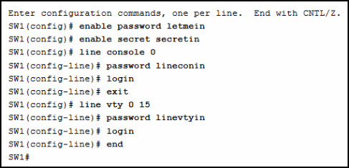

CCNA-1-v7-Modules-1-3-Basic Network Connectivity and Communications Exam Answers 14

* letmein
* secretin
* **lineconin**
* linevtyin

**Explanation:** Telnet accesses a network device through the virtual interface configured with the line VTY command. The password configured under this is required to access the user EXEC mode. The password configured under the line console 0 command is required to gain entry through the console port, and the enable and enable secret passwords are used to allow entry into the privileged EXEC mode.

**19. A technician configures a switch with these commands:**

SwitchA(config)# interface vlan 1

SwitchA(config-if)# ip address 192.168.1.1 255.255.255.0

SwitchA(config-if)# no shutdown

**What is the technician configuring?**

* Telnet access
* **SVI**
* password encryption
* physical switchport access

**Explanation:** For a switch to have an IP address, a switch virtual interface must be configured. This allows the switch to be managed remotely over the network.

**20. Which command or key combination allows a user to return to the previous level in the command hierarchy?**

* end
* **exit**
* Ctrl-Z
* Ctrl-C

**Explanation:** End and CTRL-Z return the user to the privileged EXEC mode. Ctrl-C ends a command in process. The exit command returns the user to the previous level.

**21. What are two characteristics of RAM on a Cisco device? (Choose two.)**

* RAM provides nonvolatile storage.
* **The configuration that is actively running on the device is stored in RAM.**
* **The contents of RAM are lost during a power cycle.**
* RAM is a component in Cisco switches but not in Cisco routers.
* RAM is able to store multiple versions of IOS and configuration files.

**Explanation:** RAM stores data that is used by the device to support network operations. The running configuration is stored in RAM. This type of memory is considered volatile memory because data is lost during a power cycle. Flash memory stores the IOS and delivers a copy of the IOS into RAM when a device is powered on. Flash memory is nonvolatile since it retains stored contents during a loss of power.

**22. Which two host names follow the guidelines for naming conventions on Cisco IOS devices? (Choose two.)**

* Branch2!
* **RM-3-Switch-2A4**
* Floor(15)
* HO Floor 17
* **SwBranch799**

**Explanation:** Some guidelines for naming conventions are that names should:  
Start with a letter  
Contain no spaces  
End with a letter or digit  
Use only letters, digits, and dashes  
Be less than 64 characters in length

**23. How is SSH different from Telnet?**

* SSH makes connections over the network, whereas Telnet is for out-of-band access.
* **SSH provides security to remote sessions by encrypting messages and using user authentication. Telnet is considered insecure and sends messages in plaintext.**
* SSH requires the use of the PuTTY terminal emulation program. Tera Term must be used to connect to devices through the use of Telnet.
* SSH must be configured over an active network connection, whereas Telnet is used to connect to a device from a console connection.

**Explanation:** SSH is the preferred protocol for connecting to a device operating system over the network because it is much more secure than Telnet. Both SSH and Telnet are used to connect to devices over the network, and so are both used in-band. PuTTY and Terra Term can be used to make both SSH and Telnet connections.

**24. An administrator is configuring a switch console port with a password. In what order will the administrator travel through the IOS modes of operation in order to reach the mode in which the configuration commands will be entered? (Not all options are used.)**

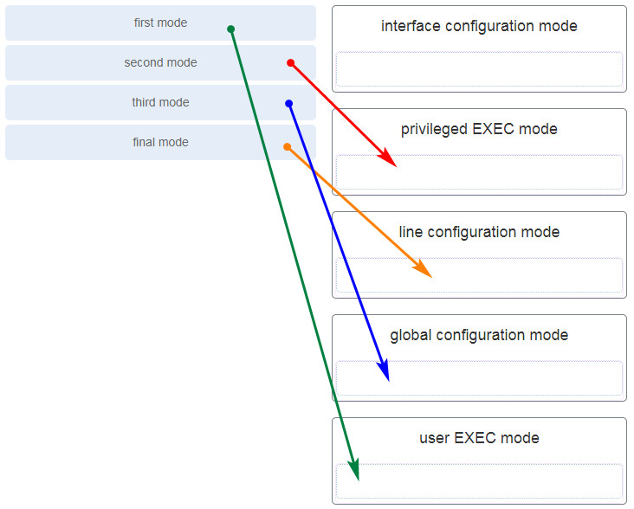

CCNA-1-v7-Modules-1-3-Basic Network Connectivity and Communications Exam Answers 24

**Explanation:** The configuration mode that the administrator first encounters is user EXEC mode. After the **enable**command is entered, the next mode is privileged EXEC mode. From there, the**configure termina**l command is entered to move to global configuration mode. Finally, the administrator enters the**line console 0**command to enter the mode in which the configuration will be entered.

**25. What are three characteristics of an SVI? (Choose three.)**

* It is designed as a security protocol to protect switch ports.
* **It is not associated with any physical interface on a switch.**
* It is a special interface that allows connectivity by different types of media.
* It is required to allow connectivity by any device at any location.
* **It provides a means to remotely manage a switch.**
* **It is associated with VLAN1 by default.**

**Explanation:** Switches have one or more switch virtual interfaces (SVIs). SVIs are created in software since there is no physical hardware associated with them. Virtual interfaces provide a means to remotely manage a switch over a network that is using IP. Each switch comes with one SVI appearing in the default configuration “out-of-the-box.” The default SVI interface is VLAN1.

**26. What command is used to verify the condition of the switch interfaces, including the status of the interfaces and a configured IP address?**

* ipconfig
* ping
* traceroute
* **show ip interface brief**

**Explanation:** The show ip interface brief command is used to display a brief synopsis of the condition of the device interfaces. The ipconfig command is used to verify TCP/IP properties on a host. The ping command is used to verify Layer 3 connectivity. The traceroute command is used to trace the network path from source to destination.

**27. Match the description with the associated IOS mode. (Not all options are used.)**  
[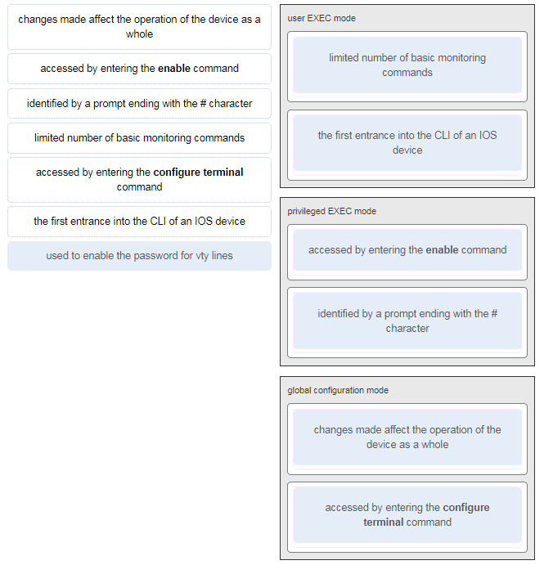](https://itexamanswers.net/wp-content/uploads/2019/12/2020-03-08_184953.jpg)

**28. Match the definitions to their respective CLI hot keys and shortcuts. (Not all options are used.)**  
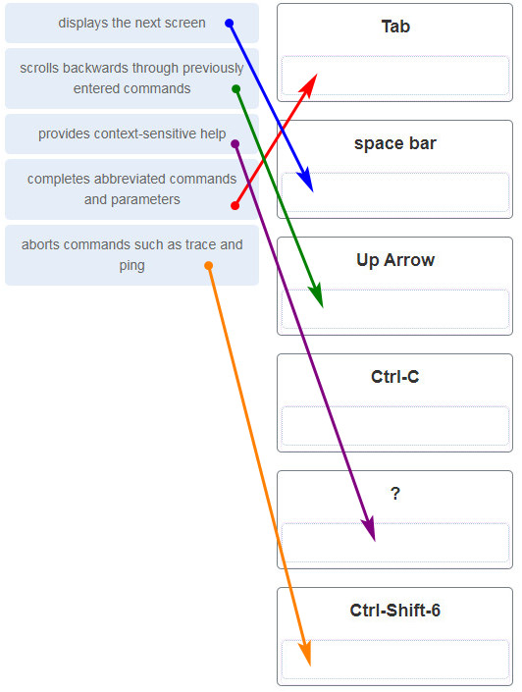

**Explanation:** The shortcuts with their functions are as follows:  
– Tab – Completes the remainder of a partially typed command or keyword  
– Space bar – displays the next screen  
– ? – provides context-sensitive help  
– Up Arrow – Allows user to scroll backward through former commands  
– Ctrl-C – cancels any command currently being entered and returns directly to privileged EXEC mode  
– Ctrl-Shift-6 – Allows the user to interrupt an IOS process such as ping or traceroute

**29. In the show running-config command, which part of the syntax is represented by running-config?**

* the command
* **a keyword**
* a variable
* a prompt

**Explanation:** The first part of the syntax, show, is the command, and the second part of the syntax, running-config, is the keyword. The keyword specifies what should be displayed as the output of the show command.

**30. After making configuration changes on a Cisco switch, a network administrator issues a copy running-config startup-config command. What is the result of issuing this command?**

* The new configuration will be stored in flash memory.
* **The new configuration will be loaded if the switch is restarted.**
* The current IOS file will be replaced with the newly configured file.
* The configuration changes will be removed and the original configuration will be restored.

**31. What command will prevent all unencrypted passwords from displaying in plain text in a configuration file?**

* (config)# enable password secret
* (config)# enable secret Secret_Password
* (config-line)# password secret
* **(config)# service password-encryption**
* (config)# enable secret Encrypted_Password

**Explanation:** To prevent all configured passwords from appearing in plain text in configuration files, an administrator can execute the service password-encryption command. This command encrypts all configured passwords in the configuration file.

**32. A network administrator enters the service password-encryption command into the configuration mode of a router. What does this command accomplish?**

* This command encrypts passwords as they are transmitted across serial WAN links.
* **This command prevents someone from viewing the running configuration passwords.**
* This command enables a strong encryption algorithm for the enable secret password command.
* This command automatically encrypts passwords in configuration files that are currently stored in NVRAM.
* This command provides an exclusive encrypted password for external service personnel who are required to do router maintenance.

**Explanation:** The startup-config and running-config files display most passwords in plaintext. Use the service password-encryption global config command to encrypt all plaintext passwords in these files.

**33. What method can be used by two computers to ensure that packets are not dropped because too much data is being sent too quickly?**

* encapsulation
* **flow control**
* access method
* response timeout

**Explanation:** In order for two computers to be able to communicate effectively, there must be a mechanism that allows both the source and destination to set the timing of the transmission and receipt of data. Flow control allows for this by ensuring that data is not sent too fast for it to be received properly.

**34. Which statement accurately describes a TCP/IP encapsulation process when a PC is sending data to the network?**

* Data is sent from the internet layer to the network access layer.
* Packets are sent from the network access layer to the transport layer.
* **Segments are sent from the transport layer to the internet layer.**
* Frames are sent from the network access layer to the internet layer.

**Explanation:** When the data is traveling from the PC to the network, the transport layer sends segments to the internet layer. The internet layer sends packets to the network access layer, which creates frames and then converts the frames to bits. The bits are released to the network media.

**35. What three application layer protocols are part of the TCP/IP protocol suite? (Choose three.)**

* ARP
* **DHCP**
* **DNS**
* **FTP**
* NAT
* PPP

**Explanation:** DNS, DHCP, and FTP are all application layer protocols in the TCP/IP protocol suite. ARP and PPP are network access layer protocols, and NAT is an internet layer protocol in the TCP/IP protocol suite.

**36. Match the description to the organization. (Not all options are used.)**

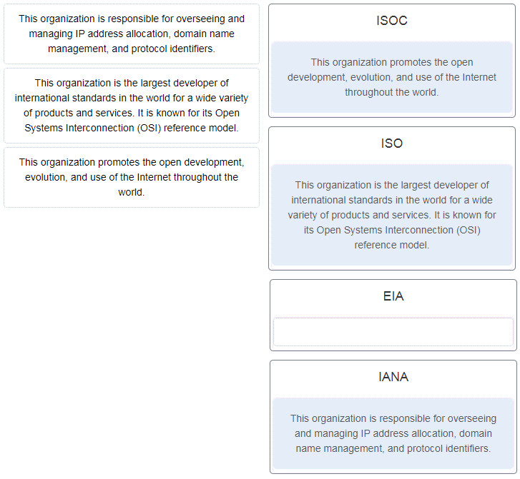

**37. Which name is assigned to the transport layer PDU?**

* bits
* data
* frame
* packet
* **segment**

**Explanation:** Application data is passed down the protocol stack on its way to be transmitted across the network media. During the process, various protocols add information to it at each level. At each stage of the process, a PDU (protocol data unit) has a different name to reflect its new functions. The PDUs are named according to the protocols of the TCP/IP suite:  
Data – The general term for the PDU used at the application layer.  
Segment – transport layer PDU  
Packet – network layer PDU  
Frame – data link layer PDU  
Bits – A physical layer PDU used when physically transmitting data over the medium

**38. When IPv4 addressing is manually configured on a web server, which property of the IPv4 configuration identifies the network and host portion for an IPv4 address?**

* DNS server address
* **subnet mask**
* default gateway
* DHCP server address

**Explanation:** There are several components that need to be entered when configuring IPv4 for an end device:  
IPv4 address – uniquely identifies an end device on the network  
Subnet mask – determines the network address portion and host portion for an IPv4 address  
Default gateway – the IP address of the router interface used for communicating with hosts in another network  
DNS server address – the IP address of the Domain Name System (DNS) server  
DHCP server address (if DHCP is used) is not configured manually on end devices. It will be provided by a DHCP server when an end device requests an IP address.

**39. What process involves placing one PDU inside of another PDU?**

* **encapsulation**
* encoding
* segmentation
* flow control

**Explanation:** When a message is placed inside of another message, this is known as encapsulation. On networks, encapsulation takes place when one protocol data unit is carried inside of the data field of the next lower protocol data unit.

**40. What layer is responsible for routing messages through an internetwork in the TCP/IP model?**

* **internet**
* transport
* network access
* session

**Explanation:** The TCP/IP model consists of four layers: application, transport, internet, and network access. Of these four layers, it is the internet layer that is responsible for routing messages. The session layer is not part of the TCP/IP model but is rather part of the OSI model.

**41. For the TCP/IP protocol suite, what is the correct order of events when a Telnet message is being prepared to be sent over the network?**

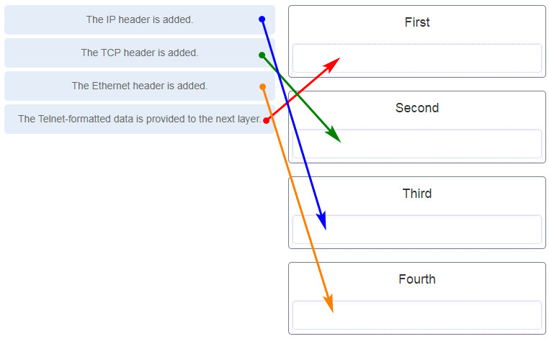

CCNA-1-v7-Modules-1-3-Basic Network Connectivity and Communications Exam Answers 41

**42. Which PDU format is used when bits are received from the network medium by the NIC of a host?**

* file
* **frame**
* packet
* segment

**Explanation:** When received at the physical layer of a host, the bits are formatted into a frame at the data link layer. A packet is the PDU at the network layer. A segment is the PDU at the transport layer. A file is a data structure that may be used at the application layer.

**43. Refer to the exhibit. ServerB is attempting to contact HostA. Which two statements correctly identify the addressing that ServerB will generate in the process? (Choose two.)**

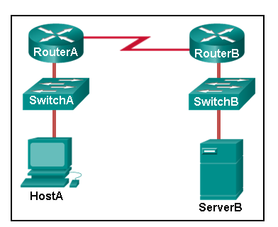

* ServerB will generate a packet with the destination IP address of RouterB.
* ServerB will generate a frame with the destination MAC address of SwitchB.
* ServerB will generate a packet with the destination IP address of RouterA.
* **ServerB will generate a frame with the destination MAC address of RouterB.**
* **ServerB will generate a packet with the destination IP address of HostA.**
* ServerB will generate a frame with the destination MAC address of RouterA.

**44. Which method allows a computer to react accordingly when it requests data from a server and the server takes too long to respond?**

* encapsulation
* flow control
* access method
* **response timeout**

**45. A web client is receiving a response for a web page from a web server. From the perspective of the client, what is the correct order of the protocol stack that is used to decode the received transmission?**

* **Ethernet, IP, TCP, HTTP**
* HTTP, TCP, IP, Ethernet
* Ethernet, TCP, IP, HTTP
* HTTP, Ethernet, IP, TCP

**Explanation:**  
1. HTTP governs the way that a web server and client interact.  
2. TCP manages individual conversations between web servers and clients.  
3. IP is responsible for delivery across the best path to the destination.  
4. Ethernet takes the packet from IP and formats it for transmission.

**46. Which two OSI model layers have the same functionality as a single layer of the TCP/IP model? (Choose two.)**

* **data link**
* network
* **physical**
* session
* transport

**Explanation:** The OSI data link and physical layers together are equivalent to the TCP/IP network access layer. The OSI transport layer is functionally equivalent to the TCP/IP transport layer, and the OSI network layer is equivalent to the TCP/IP internet layer. The OSI application, presentation, and session layers are functionally equivalent to the application layer within the TCP/IP model.

**47. At which layer of the OSI model would a logical address be added during encapsulation?**

* physical layer
* data link layer
* **network layer**
* transport layer

**48. What is a characteristic of multicast messages?**

* **They are sent to a select group of hosts.**
* They are sent to all hosts on a network.
* They must be acknowledged.
* They are sent to a single destination.

**Explanation:** Multicast is a one-to-many type of communication. Multicast messages are addressed to a specific multicast group.

**49. Which statement is correct about network protocols?**

* Network protocols define the type of hardware that is used and how it is mounted in racks.
* **They define how messages are exchanged between the source and the destination.**
* They all function in the network access layer of TCP/IP.
* They are only required for exchange of messages between devices on remote networks.

**50. What is an advantage of network devices using open standard protocols?**

* Network communications is confined to data transfers between devices from the same vendor.
* **A client host and a server running different operating systems can successfully exchange data.**
* Internet access can be controlled by a single ISP in each market.
* Competition and innovation are limited to specific types of products.

**Explanation:** An advantage of network devices implementing open standard protocols, such as from the TCP/IP suite, is that clients and servers running different operating systems can communicate with each other. Open standard protocols facilitate innovation and competition between vendors and across markets, and can reduce the occurrence of monopolies in networking markets.

**51. Which device performs the function of determining the path that messages should take through internetworks?**

* **a router**
* a firewall
* a web server
* a DSL modem

**Explanation:** A router is used to determine the path that the messages should take through the network. A firewall is used to filter incoming and outgoing traffic. A DSL modem is used to provide Internet connection for a home or an organization.

**52. Open the PT Activity. Perform the tasks in the activity instructions and then answer the question.**

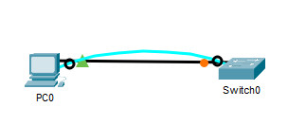

CCNA-1-v7-Modules-1-3-Basic Network Connectivity and Communications Exam Answers 52

**This content is locked!**

Please support us, use one of the buttons below to unlock the content.

[error](https://itexamanswers.net/ccna-1-v7-modules-1-3-basic-network-connectivity-and-communications-exam-answers.html)

**What is the IP address of the switch virtual interface (SVI) on Switch0?**

* **192.168.5.10**
* 192.168.10.5
* 192.168.10.1
* 192.168.5.0

**Explanation:** After the enable command is issued, the show running-configuration command or the show ip interfaces brief command will display the IP address of the switch virtual interface (SVI).

**53. Why would a Layer 2 switch need an IP address?**

* to enable the switch to send broadcast frames to attached PCs
* to enable the switch to function as a default gateway
* **to enable the switch to be managed remotely**
* to enable the switch to receive frames from attached PCs

**Explanation:** A switch, as a Layer 2 device, does not need an IP address to transmit frames to attached devices. However, when a switch is accessed remotely through the network, it must have a Layer 3 address. The IP address must be applied to a virtual interface rather than to a physical interface. Routers, not switches, function as default gateways.

**54. Refer to the exhibit. An administrator is trying to configure the switch but receives the error message that is displayed in the exhibit. What is the problem?**

CCNA-1-v7-Modules-1-3-Basic Network Connectivity and Communications Exam Answers 50

CCNA-1-v7-Modules-1-3-Basic Network Connectivity and Communications Exam Answers 54

* The entire command, configure terminal, must be used.
* The administrator is already in global configuration mode.
* **The administrator must first enter privileged EXEC mode before issuing the command.**
* The administrator must connect via the console port to access global configuration mode.

**Explanation:** In order to enter global configuration mode, the command configure terminal, or a shortened version such as config t, must be entered from privileged EXEC mode. In this scenario the administrator is in user EXEC mode, as indicated by the > symbol after the hostname. The administrator would need to use the enable command to move into privileged EXEC mode before entering the configure terminal command.

**55. What term describes a network owned by one organization that provides safe and secure access to individuals who work for a different organization?**

* **extranet**
* cloud
* BYOD
* quality of service

**56. What term describes storing personal files on servers over the internet to provide access anywhere, anytime, and on any device?**

* **cloud**
* BYOD
* quality of service
* converged network

**57. What term describes a network where one computer can be both client and server?**

* **peer-to-peer**
* cloud
* BYOD
* quality of service

**58. What term describes a type of network used by people who work from home or from a small remote office?**

* **SOHO network**
* BYOD
* quality of service
* converged network

**59. What term describes a computing model where server software runs on dedicated computers?**

* **client/server**
* internet
* intranet
* extranet

**60. What term describes a type of network used by people who work from home or from a small remote office?**

* **SOHO network**
* internet
* intranet
* extranet

**61. What term describes a technology that allows devices to connect to the LAN using an electrical outlet?**

* **powerline networking**
* internet
* intranet
* extranet

**62. What term describes a policy that allows network devices to manage the flow of data to give priority to voice and video?**

* **quality of service**
* internet
* intranet
* extranet

**63. What term describes a private collection of LANs and WANs that belongs to an organization?**

* **intranet**
* internet
* extranet
* peer-to-peer

**64. What term describes the ability to use personal devices across a business or campus network?**

* **BYOD**
* internet
* intranet
* extranet

**65. At which OSI layer is a source IP address added to a PDU during the encapsulation process?**

* **network layer**
* data link layer
* transport layer
* application layer

**66. At which OSI layer is a destination port number added to a PDU during the encapsulation process?**

* **transport layer**
* data link layer
* network layer
* application layer

**67. At which OSI layer is data added to a PDU during the encapsulation process?**

* **application layer**
* data link layer
* network layer
* transport layer

**68. At which OSI layer is a source IP address added to a PDU during the encapsulation process?**

* **network layer**
* data link layer
* application layer
* presentation layer

**70. At which OSI layer is a destination IP address added to a PDU during the encapsulation process?**

* **network layer**
* application layer
* transport layer
* presentation layer

**71. At which OSI layer is a source MAC address added to a PDU during the encapsulation process?**

* **data link layer**
* application layer
* transport layer
* presentation layer

**72. At which OSI layer is a source port number added to a PDU during the encapsulation process?**

* **transport layer**
* application layer
* network layer
* presentation layer
* data link layer

**73. At which OSI layer is a destination MAC address added to a PDU during the encapsulation process?**

* **data link layer**
* transport layer
* application layer
* network layer

**1. What is the purpose of the OSI physical layer?**

* controlling access to media
* **transmitting bits across the local media**
* performing error detection on received frames
* exchanging frames between nodes over physical network media

**2. Why are two strands of fiber used for a single fiber optic connection?**

* The two strands allow the data to travel for longer distances without degrading.
* They prevent crosstalk from causing interference on the connection.
* They increase the speed at which the data can travel.
* **They allow for full-duplex connectivity.**

**3. Which characteristic describes crosstalk?**

* the distortion of the network signal from fluorescent lighting
* **the distortion of the transmitted messages from signals carried in adjacent wires**
* the weakening of the network signal over long cable lengths
* the loss of wireless signal over excessive distance from the access point

**4. Which procedure is used to reduce the effect of crosstalk in copper cables?**

* requiring proper grounding connections
* **twisting opposing circuit wire pairs together**
* wrapping the bundle of wires with metallic shielding
* designing a cable infrastructure to avoid crosstalk interference
* avoiding sharp bends during installation

**5. Match the situation with the appropriate use of network media.**

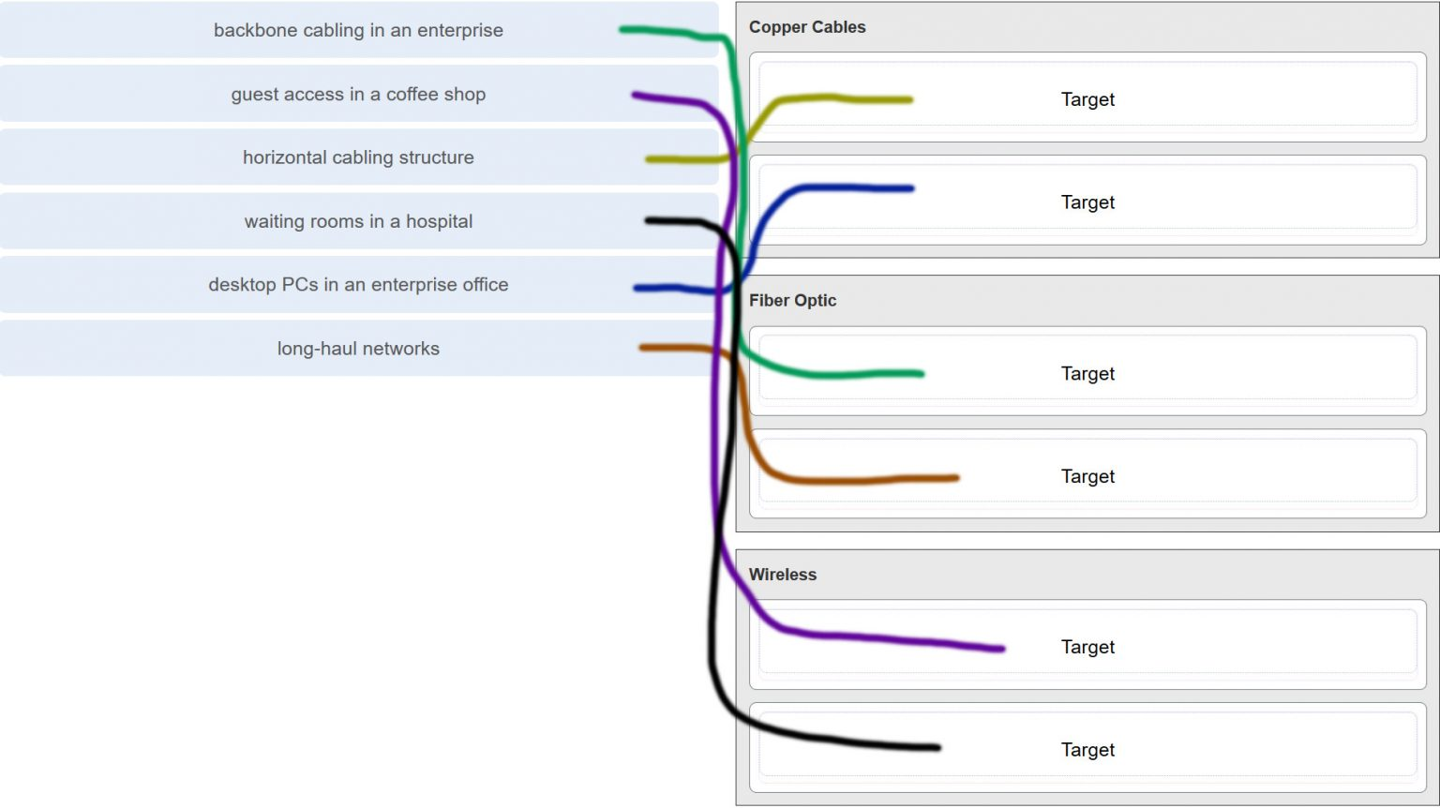

**6. A network administrator is measuring the transfer of bits across the company backbone for a mission critical financial application. The administrator notices that the network throughput appears lower than the bandwidth expected. Which three factors could influence the differences in throughput? (Choose three.)**

* **the amount of traffic that is currently crossing the network**
* the sophistication of the encapsulation method applied to the data
* **the type of traffic that is crossing the network**
* **the latency that is created by the number of network devices that the data is crossing**
* the bandwidth of the WAN connection to the Internet
* the reliability of the gigabit Ethernet infrastructure of the backbone

**Explanation:** Throughput usually does not match the specified bandwidth of physical links due to multiple factors. These factors include, the amount of traffic, type of traffic, and latency created by the network devices the data has to cross.

**7. What are two characteristics of fiber-optic cable? (Choose two.)**

* **It is not affected by EMI or RFI.**
* Each pair of cables is wrapped in metallic foil.
* It combines the technique of cancellation, shielding, and twisting to protect data.
* It typically contains 4 pairs of fiber-optic wires.
* **It is more expensive than UTP cabling is.**

**Explanation:** Fiber-optic cabling supports higher bandwidth than UTP for longer distances. Fiber is immune to EMI and RFI, but costs more, requires more skill to install, and requires more safety precautions.

**8. What is a primary role of the Physical layer in transmitting data on the network?**

* **create the signals that represent the bits in each frame on to the media**
* provide physical addressing to the devices
* determine the path packets take through the network
* control data access to the media

**Explanation:** The OSI physical layer provides the means to transport the bits that make up a frame across the network media. This layer accepts a complete frame from the data link layer and encodes it as a series of signals that are transmitted to the local media.

**9. With the use of unshielded twisted-pair copper wire in a network, what causes crosstalk within the cable pairs?**

* **the magnetic field around the adjacent pairs of wire**
* the use of braided wire to shield the adjacent wire pairs
* the reflection of the electrical wave back from the far end of the cable
* the collision caused by two nodes trying to use the media simultaneously

**Explanation:** Crosstalk is a type of noise, or interference that occurs when signal transmission on one wire interferes with another wire. When current flows through a wire a magnetic field is produced. The produced magnetic field will interface the signal carried in the adjacent wire.

**10. Refer to the graphic. What type of cabling is shown?**  
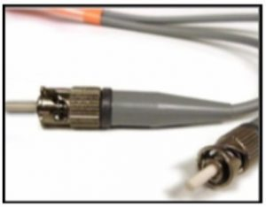

* STP
* UTP
* coax
* **fiber**

**Explanation:** Network cabling include different types of cables:

* UTP cable consists of four pairs of color-coded wires that have been twisted together and then encased in a flexible plastic sheath.
* STP cable uses four pairs of wires, each wrapped in a foil shield, which are then wrapped in an overall metallic braid or foil.
* Coaxial cable uses a copper conductor and a layer of flexible plastic insulation surrounds the copper conductor.
* Fiber cable is a flexible, extremely thin, transparent strand of glass surrounded by plastic insulation.

**11. In addition to the cable length, what two factors could interfere with the communication carried over UTP cables? (Choose two.)**

* **crosstalk**
* bandwidth
* size of the network
* signal modulation technique
* **electromagnetic interference**

**Explanation:** Copper media is widely used in network communications. However, copper media is limited by distance and signal interference. Data is transmitted on copper cables as electrical pulses. The electrical pulses are susceptible to interference from two sources:

* **Electromagnetic interference (EMI) or radio frequency interference (RFI)** – EMI and RFI signals can distort and corrupt the data signals being carried by copper media.
* **Crosstalk** – Crosstalk is a disturbance caused by the electric or magnetic fields of a signal on one wire interfering with the signal in an adjacent wire.

**12. Refer to the graphic. What type of cabling is shown?**

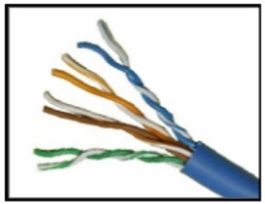

* STP
* **UTP**
* coax
* fiber

**13. Which two devices commonly affect wireless networks? (Choose two.)**

* Blu-ray players
* home theaters
* **cordless phones**
* **microwaves**
* incandescent light bulbs
* external hard drives

**Explanation:** Radio Frequency Interference (RFI) is the interference that is caused by radio transmitters and other devices that are transmitting in the same frequency.

**14. Which two statements describe the services provided by the data link layer? (Choose two.)**

* It defines the end-to-end delivery addressing scheme.
* It maintains the path between the source and destination devices during the data transmission.
* **It manages the access of frames to the network media.**
* It provides reliable delivery through link establishment and flow control.
* It ensures that application data will be transmitted according to the prioritization.
* **It packages various Layer 3 PDUs into a frame format that is compatible with the network interface.**

**Explanation:** The data link layer is divided into two sub layers, namely Logical Link Control (LLC) and Media Access Control (MAC). LLC forms a frame from the network layer PDU into a format that conforms to the requirements of the network interface and media. A network layer PDU might be for IPv4 or IPv6. The MAC sub layer defines the media access processes performed by the hardware. It manages the frame access to the network media according to the physical signaling requirements (copper cable, fiber optic, wireless, etc.)

**15. What is the function of the CRC value that is found in the FCS field of a frame?**

* **to verify the integrity of the received frame**
* to verify the physical address in the frame
* to verify the logical address in the frame
* to compute the checksum header for the data field in the frame

**16. What is contained in the trailer of a data-link frame?**

* logical address
* physical address
* data
* **error detection**

**17. Which statement describes a characteristic of the frame header fields of the data link layer?**

* They all include the flow control and logical connection fields.
* Ethernet frame header fields contain Layer 3 source and destination addresses.
* **They vary depending on protocols.**
* They include information on user applications.

**Explanation:** All data link layer protocols encapsulate the Layer 3 PDU within the data field of the frame. However, the structure of the frame and the fields that are contained in the header vary according to the protocol. Different data link layer protocols may use different fields, like priority/quality of service, logical connection control, physical link control, flow control, and congestion control.

**18. A network team is comparing physical WAN topologies for connecting remote sites to a headquarters building. Which topology provides high availability and connects some, but not all, remote sites?**

* mesh
* **partial mesh**
* hub and spoke
* point-to-point

**Explanation:** Partial mesh topologies provide high availability by interconnecting multiple remote sites, but do not require a connection between all remote sites. A mesh topology requires point-to-point links with every system being connected to every other system. A point-to-point topology is where each device is connected to one other device. A hub and spoke uses a central device in a star topology that connects to other point-to-point devices.

**19. Which two fields or features does Ethernet examine to determine if a received frame is passed to the data link layer or discarded by the NIC? (Choose two.)**

* auto-MDIX
* CEF
* **Frame Check Sequence**
* **minimum frame size**
* source MAC address

**20. Which media communication type does not require media arbitration in the data link layer?**

* deterministic
* half-duplex
* **full-duplex**
* controlled access

**Explanation:** Half-duplex communication occurs when both devices can both transmit and receive on the medium but cannot do so simultaneously. Full-duplex communication occurs when both devices can transmit and receive on the medium at the same time and therefore does not require media arbitration. Half-duplex communication is typically contention-based, whereas controlled (deterministic) access is applied in technologies where devices take turns to access the medium.

**21. Which statement describes an extended star topology?**

* **End devices connect to a central intermediate device, which in turn connects to other central intermediate devices.**
* End devices are connected together by a bus and each bus connects to a central intermediate device.
* Each end system is connected to its respective neighbor via an intermediate device.
* All end and intermediate devices are connected in a chain to each other.

**Explanation:** In an extended star topology, central intermediate devices interconnect other star topologies.

**22. What is a characteristic of the LLC sublayer?**

* It provides the logical addressing required that identifies the device.
* It provides delimitation of data according to the physical signaling requirements of the medium.
* **It places information in the frame allowing multiple Layer 3 protocols to use the same network interface and media.**
* It defines software processes that provide services to the physical layer.

**23. What are three ways that media access control is used in networking? (Choose three.)**

* **Ethernet utilizes CSMA/CD.**
* **Media access control provides placement of data frames onto the media.**
* Contention-based access is also known as deterministic.
* 802.11 utilizes CSMA/CD.
* **Data link layer protocols define the rules for access to different media.**
* Networks with controlled access have reduced performance due to data collisions.

**24. During the encapsulation process, what occurs at the data link layer for a PC connected to an Ethernet network?**

* An IP address is added.
* The logical address is added.
* **The physical address is added.**
* The process port number is added.

**Explanation:** The Ethernet frame includes the source and destination physical address. The trailer includes a CRC value in the Frame Check Sequence field to allow the receiving device to determine if the frame has been changed (has errors) during the transmission.

**25. What three items are contained in an Ethernet header and trailer? (Choose three.)**

* source IP address
* **source MAC address**
* destination IP address
* **destination MAC address**
* **error-checking information**

**Explanation:** Layer 2 headers contain the following:

* Frame start and stop indicator flags at the beginning and end of a frame
* Addressing – for Ethernet networks this part of the header contains source and destination MAC addresses
* Type field to indicate what Layer 3 protocol is being used
* Error detection to determine if the frame arrived without error

**26. What type of communication rule would best describe CSMA/CD?**

* **access method**
* flow control
* message encapsulation
* message encoding

**Explanation:** Carrier sense multiple access collision detection (CSMA/CD) is the access method used with Ethernet. The access method rule of communication dictates how a network device is able to place a signal on the carrier. CSMA/CD dictates those rules on an Ethernet network and CSMA/CA dictates those rules on an 802.11 wireless LAN.

**27. Which three basic parts are common to all frame types supported by the data link layer? (Choose three.)**

* **header**
* type field
* MTU size
* **data**
* **trailer**
* CRC value

**Explanation:** The data link protocol is responsible for NIC-to-NIC communications within the same network. Although there are many different data link layer protocols that describe data link layer frames, each frame type has three basic parts:

* Header
* Data
* Trailer

**28. Which statement is true about the CSMA/CD access method that is used in Ethernet?**

* When a device hears a carrier signal and transmits, a collision cannot occur.
* A jamming signal causes only devices that caused the collision to execute a backoff algorithm.
* **All network devices must listen before transmitting.**
* Devices involved in a collision get priority to transmit after the backoff period.

**29. What is the auto-MDIX feature on a switch?**

* the automatic configuration of an interface for 10/100/1000 Mb/s operation
* **the automatic configuration of an interface for a straight-through or a crossover Ethernet cable connection**
* the automatic configuration of full-duplex operation over a single Ethernet copper or optical cable
* the ability to turn a switch interface on or off accordingly if an active connection is detected

**Explanation:** The auto-MDIX enables a switch to use a crossover or a straight-through Ethernet cable to connect to a device regardless of the device on the other end of the connection.

**30. Refer to the exhibit. What is the destination MAC address of the Ethernet frame as it leaves the web server if the final destination is PC1?**

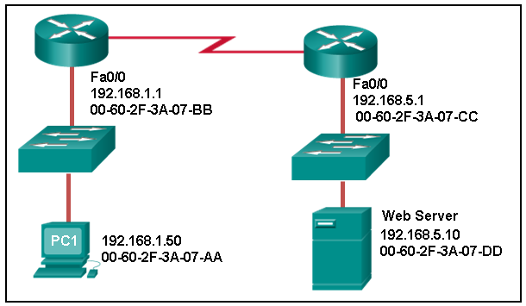

* 00-60-2F-3A-07-AA
* 00-60-2F-3A-07-BB
* **00-60-2F-3A-07-CC**
* 00-60-2F-3A-07-DD

**Explanation:** The destination MAC address is used for local delivery of Ethernet frames. The MAC (Layer 2) address changes at each network segment along the path. As the frame leaves the web server, it will be delivered by using the MAC address of the default gateway.

**31. A Layer 2 switch is used to switch incoming frames from a 1000BASE-T port to a port connected to a 100Base-T network. Which method of memory buffering would work best for this task?**

* port-based buffering
* level 1 cache buffering
* **shared memory buffering**
* fixed configuration buffering

**Explanation:** With shared memory buffering, the number of frames stored in the buffer is restricted only by the of the entire memory buffer and not limited to a single port buffer. This permits larger frames to be transmitted with fewer dropped frames. This is important to asymmetric switching, which applies to this scenario, where frames are being exchanged between ports of different rates. With port-based memory buffering, frames are stored in queues that are linked to specific incoming and outgoing ports making it possible for a single frame to delay the transmission of all the frames in memory because of a busy destination port. Level 1 cache is memory used in a CPU. Fixed configuration refers to the port arrangement in switch hardware.

**32. What are two examples of the cut-through switching method? (Choose two.)**

* store-and-forward switching
* **fast-forward switching**
* CRC switching
* **fragment-free switching**
* QOS switching

**Explanation:** Store-and forward switching accepts the entire frame and performs error checking using CRC before forwarding the frame. Store-and-forward is often required for QOS analysis. Fast-forward and fragment-free are both variations of the cut-through switching method where only part of the frame is received before the switch begins to forward it.

**33. Which frame forwarding method receives the entire frame and performs a CRC check to detect errors before forwarding the frame?**

* cut-through switching
* **store-and-forward switching**
* fragment-free switching
* fast-forward switching

**Explanation:** Fast-forward and fragment-free switching are variations of cut-through switching, which begins to forward the frame before the entire frame is received.

**34. What is the purpose of the FCS field in a frame?**

* to obtain the MAC address of the sending node
* to verify the logical address of the sending node
* to compute the CRC header for the data field
* **to determine if errors occurred in the transmission and reception**

**Explanation:** The FCS field in a frame is used to detect any errors in the transmission and receipt of a frame. This is done by comparing the CRC value within the frame against a computed CRC value of the frame. If the two values do not match, then the frame is discarded.

**35. Which switching method has the lowest level of latency?**

* cut-through
* store-and-forward
* fragment-free
* **fast-forward**

**Explanation:** Fast-forward switching begins to forward a frame after reading the destination MAC address, resulting in the lowest latency. Fragment-free reads the first 64 bytes before forwarding. Store-and-forward has the highest latency because it reads the entire frame before beginning to forward it. Both fragment-free and fast-forward are types of cut-through switching.

**36. A network administrator is connecting two modern switches using a straight-through cable. The switches are new and have never been configured. Which three statements are correct about the final result of the connection? (Choose three.)**

* **The link between the switches will work at the fastest speed that is supported by both switches.**
* **The link between switches will work as full-duplex.**
* If both switches support different speeds, they will each work at their own fastest speed.
* **The auto-MDIX feature will configure the interfaces eliminating the need for a crossover cable.**
* The connection will not be possible unless the administrator changes the cable to a crossover cable.
* The duplex capability has to be manually configured because it cannot be negotiated.

**Explanation:** Modern switches can negotiate to work in full-duplex mode if both switches are capable. They will negotiate to work using the fastest possible speed and the auto-MDIX feature is enabled by default, so a cable change is not needed.

**37. Which advantage does the store-and-forward switching method have compared with the cut-through switching method?**

* collision detecting
* **frame error checking**
* faster frame forwarding
* frame forwarding using IPv4 Layer 3 and 4 information

**Explanation:** A switch using the store-and-forward switching method performs an error check on an incoming frame by comparing the FCS value against its own FCS calculations after the entire frame is received. In comparison, a switch using the cut-through switching method makes quick forwarding decisions and starts the forwarding process without waiting for the entire frame to be received. Thus a switch using cut-through switching may send invalid frames to the network. The performance of store-and-forward switching is slower compared to cut-through switching performance. Collision detection is monitored by the sending device. Store-and-forward switching does not use IPv4 Layer 3 and 4 information for its forwarding decisions.

**38. When the store-and-forward method of switching is in use, what part of the Ethernet frame is used to perform an error check?**

* **CRC in the trailer**
* source MAC address in the header
* destination MAC address in the header
* protocol type in the header

**Explanation:** The cyclic redundancy check (CRC) part of the trailer is used to determine if the frame has been modified during transit.​ If the integrity of the frame is verified, the frame is forwarded. If the integrity of the frame cannot be verified, then the frame is dropped.

**39. Which switching method uses the CRC value in a frame?**

* cut-through
* fast-forward
* fragment-free
* **store-and-forward**

**Explanation:** When the store-and-forward switching method is used, the switch receives the complete frame before forwarding it on to the destination. The cyclic redundancy check (CRC) part of the trailer is used to determine if the frame has been modified during transit.​​ In contrast, a cut-through switch forwards the frame once the destination Layer 2 address is read. Two types of cut-through switching methods are fast-forward and fragment-free.

**40. What are two actions performed by a Cisco switch? (Choose two.)**

* building a routing table that is based on the first IP address in the frame header
* **using the source MAC addresses of frames to build and maintain a MAC address table**
* forwarding frames with unknown destination IP addresses to the default gateway
* **utilizing the MAC address table to forward frames via the destination MAC address**
* examining the destination MAC address to add new entries to the MAC address table

**Explanation:** Important actions that a switch performs are as follows:

* When a frame comes in, the switch examines the Layer 2 source address to build and maintain the Layer 2 MAC address table.
* It examines the Layer 2 destination address to determine how to forward the frame. When the destination address is in the MAC address table, then the frame is sent out a particular port. When the address is unknown, the frame is sent to all ports that have devices connected to that network.

**41. Which two statements describe features or functions of the logical link control sublayer in Ethernet standards? (Choose two.)**

* **Logical link control is implemented in software.**
* Logical link control is specified in the IEEE 802.3 standard.
* The LLC sublayer adds a header and a trailer to the data.
* **The data link layer uses LLC to communicate with the upper layers of the protocol suite.**
* The LLC sublayer is responsible for the placement and retrieval of frames on and off the media.

**Explanation:** Logical link control is implemented in software and enables the data link layer to communicate with the upper layers of the protocol suite. Logical link control is specified in the IEEE 802.2 standard. IEEE 802.3 is a suite of standards that define the different Ethernet types. The MAC (Media Access Control) sublayer is responsible for the placement and retrieval of frames on and off the media. The MAC sublayer is also responsible for adding a header and a trailer to the network layer protocol data unit (PDU).

**42. What is the auto-MDIX feature?**

* **It enables a device to automatically configure an interface to use a straight-through or a crossover cable.**
* It enables a device to automatically configure the duplex settings of a segment.
* It enables a device to automatically configure the speed of its interface.
* It enables a switch to dynamically select the forwarding method.

**Explanation:** The auto-MDIX feature allows the device to configure its network port according to the cable type that is used (straight-through or crossover) and the type of device that is connected to that port. When a port of a switch is configured with auto-MDIX, this switch can be connected to another switch by the use of either a straight-through cable or a crossover cable.

**43. What is one advantage of using the cut-through switching method instead of the store-and-forward switching method?**

* has a positive impact on bandwidth by dropping most of the invalid frames
* makes a fast forwarding decision based on the source MAC address of the frame
* **has a lower latency appropriate for high-performance computing applications​**
* provides the flexibility to support any mix of Ethernet speeds

**Explanation:** Cut-through switching provides lower latency switching for high-performance computing (HPC) applications. Cut-through switching allows more invalid frames to cross the network than store-and-forward switching. The cut-through switching method can make a forwarding decision as soon as it looks up the destination MAC address of the frame.

**44. Which is a multicast MAC address?**

* FF-FF-FF-FF-FF-FF
* 5C-26-0A-4B-19-3E
* **01-00-5E-00-00-03**
* 00-26-0F-4B-00-3E

**45. Refer to the exhibit. What is wrong with the displayed termination?**

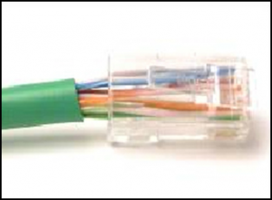

* The woven copper braid should not have been removed.
* The wrong type of connector is being used.
* **The untwisted length of each wire is too long.**
* The wires are too thick for the connector that is used.

**Explanation:** When a cable to an RJ-45 connector is terminated, it is important to ensure that the untwisted wires are not too long and that the flexible plastic sheath surrounding the wires is crimped down and not the bare wires. None of the colored wires should be visible from the bottom of the jack.

**46. Refer to the exhibit. The PC is connected to the console port of the switch. All the other connections are made through FastEthernet links. Which types of UTP cables can be used to connect the devices?​**

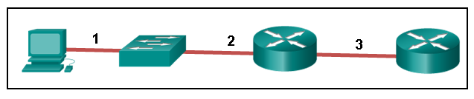

* 1 – rollover, 2 – crossover, 3 – straight-through
* **1 – rollover, 2 – straight-through, 3 – crossover**
* 1 – crossover, 2 – straight-through, 3 – rollover
* 1 – crossover, 2 – rollover, 3 – straight-through

**Explanation:** A straight-through cable is commonly used to interconnect a host to a switch and a switch to a router. A crossover cable is used to interconnect similar devices together like switch to a switch, a host to a host, or a router to a router. If a switch has the MDIX capability, a crossover could be used to connect the switch to the router; however, that option is not available. A rollover cable is used to connect to a router or switch console port.

**47. Open the PT Activity. Perform the tasks in the activity instructions and then answer the question.**  
[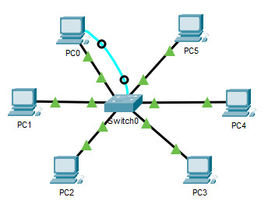](https://itexamanswers.net/wp-content/uploads/2019/12/2020-03-08_212125-1.jpg)

**This content is locked!**

Please support us, use one of the buttons below to unlock the content.

[error](https://itexamanswers.net/ccna-1-v7-modules-4-7-ethernet-concepts-exam-answers.html)

**Which port does Switch0 use to send frames to the host with the IPv4 address 10.1.1.5?**

* Fa0/1
* Fa0/5
* Fa0/9
* **Fa0/11**

**Explanation:** Issuing the command **ipconfig /all** from the PC0 command prompt displays the IPv4 address and MAC address. When the IPv4 address 10.1.1.5 is pinged from PC0, the switch stores the source MAC address (from PC0) along with the port to which PC0 is connected. When the destination reply is received, the switch takes the destination MAC address and compares to MAC addresses stored in the MAC address table. Issuing the **show mac-address-table** on the PC0 Terminal application displays two dynamic MAC address entries. The MAC address and port entry that does not belong to PC0 must be the MAC address and port of the destination with the IPv4 address 10.1.1.5.

**48. What does the term “attenuation” mean in data communication?**

* **loss of signal strength as distance increases**
* time for a signal to reach its destination
* leakage of signals from one cable pair to another
* strengthening of a signal by a networking device

**Explanation:** Data is transmitted on copper cables as electrical pulses. A detector in the network interface of a destination device must receive a signal that can be successfully decoded to match the signal sent. However, the farther the signal travels, the more it deteriorates. This is referred to as signal attenuation.

**49. What makes fiber preferable to copper cabling for interconnecting buildings? (Choose three.)**

* **greater distances per cable run**
* lower installation cost
* **limited susceptibility to EMI/RFI**
* durable connections
* **greater bandwidth potential**
* easily terminated

**Explanation:** Optical fiber cable transmits data over longer distances and at higher bandwidths than any other networking media. Unlike copper wires, fiber-optic cable can transmit signals with less attenuation and is completely immune to EMI and RFI.

**50. What OSI physical layer term describes the process by which one wave modifies another wave?**

* **modulation**
* IEEE
* EIA/TIA
* air

**51. What OSI physical layer term describes the capacity at which a medium can carry data?**

* **bandwidth**
* IEEE
* EIA/TIA
* air

**52. What OSI physical layer term describes the capacity at which a medium can carry data?**

* **bandwidth**
* throughput
* latency
* goodput

**53. What OSI physical layer term describes the measure of the transfer of bits across a medium over a given period of time?**

* **throughput**
* bandwidth
* latency
* goodput

**54. What OSI physical layer term describes the amount of time, including delays, for data to travel from one point to another?**

* **latency**
* bandwidth
* throughput
* goodput

**55. What OSI physical layer term describes the amount of time, including delays, for data to travel from one point to another?**

* **latency**
* fiber-optic cable
* air
* copper cable

**56. What OSI physical layer term describes the measure of usable data transferred over a given period of time?**

* **goodput**
* fiber-optic cable
* air
* copper cable

**57. What OSI physical layer term describes the physical medium which uses electrical pulses?**

* **copper cable**
* fiber-optic cable
* air
* goodput

**58. What OSI physical layer term describes the physical medium that uses the propagation of light?**

* **fiber-optic cable**
* goodput
* latency
* throughput

**59. What OSI physical layer term describes the physical medium for microwave transmissions?**

* **air**
* goodput
* latency
* throughput

**60. Which two functions are performed at the MAC sublayer of the OSI data link layer? (Choose two.)**

* **Implements a trailer to detect transmission errors.**
* **Controls the NIC responsible for sending and receiving data on the physical medium.**
* Places information in the frame that identifies which network layer protocol is being used for the frame.
* Adds Layer 2 control information to network protocol data.
* Enables IPv4 and IPv6 to utilize the same network interface and media.

**61. Which two functions are performed at the LLC sublayer of the OSI data link layer? (Choose two.)**

* **Enables IPv4 and IPv6 to utilize the same network interface and media.**
* **Places information in the frame that identifies which network layer protocol is being used for the frame.**
* Integrates various physical technologies.
* Implements a process to delimit fields within a Layer 2 frame.
* Controls the NIC responsible for sending and receiving data on the physical medium.

**64. Which two functions are performed at the LLC sublayer of the OSI data link layer? (Choose two.)**

* **Adds Layer 2 control information to network protocol data.**
* **Places information in the frame that identifies which network layer protocol is being used for the frame.**
* Performs data encapsulation.
* Controls the NIC responsible for sending and receiving data on the physical medium.
* Integrates various physical technologies.

**66. Which two functions are performed at the LLC sublayer of the OSI data link layer? (Choose two.)**

* **Adds Layer 2 control information to network protocol data.**
* **Enables IPv4 and IPv6 to utilize the same network interface and media.**
* Provides data link layer addressing.
* Implements a trailer to detect transmission errors.
* Provides synchronization between source and target nodes.

**68. Which two functions are performed at the LLC sublayer of the OSI data link layer? (Choose two.)**

* **Enables IPv4 and IPv6 to utilize the same network interface and media.**
* **Adds Layer 2 control information to network protocol data.**
* Integrates various physical technologies.
* Implements a trailer to detect transmission errors.
* Provides synchronization between source and target nodes.

**70. What action will occur if a switch receives a frame and does have the source MAC address in the MAC table?**

* **The switch refreshes the timer on that entry.**
* The switch shares the MAC address table entry with any connected switches.
* The switch does not forward the frame.
* The switch sends the frame to a connected router because the destination MAC address is not local.

**71. What action will occur if a switch receives a frame with the destination MAC address FF:FF:FF:FF:FF:FF?**

* **The switch forwards it out all ports except the ingress port.**
* The switch shares the MAC address table entry with any connected switches.
* The switch does not forward the frame.
* The switch sends the frame to a connected router because the destination MAC address is not local.

**72. What action will occur if a host receives a frame with a destination MAC address it does not recognize?**

* **The host will discard the frame.**
* The host sends the frame to the switch to update the MAC address table.
* The host forwards the frame to the router.
* The host forwards the frame to all other hosts.

**73. What action will occur if a switch receives a frame with the destination MAC address 01:00:5E:00:00:D9?**

* **The switch forwards it out all ports except the ingress port.**
* The switch does not forward the frame.
* The switch sends the frame to a connected router because the destination MAC address is not local.
* The switch shares the MAC address table entry with any connected switches.

**74. What action will occur if a host receives a frame with a destination MAC address of FF:FF:FF:FF:FF:FF?**

* **The host will process the frame.**
* The host forwards the frame to the router.
* The host sends the frame to the switch to update the MAC address table.
* The host forwards the frame to all other hosts.

**75. What action will occur if a switch receives a frame and does have the source MAC address in the MAC table?**

* **The switch refreshes the timer on that entry.**
* The switch adds it to its MAC address table associated with the port number.
* The switch forwards the frame to the associated port.
* The switch sends the frame to a connected router because the destination MAC address is not local.

**76. What action will occur if a host receives a frame with a destination MAC address of FF:FF:FF:FF:FF:FF?**

* **The host will process the frame.**
* The host returns the frame to the switch.
* The host replies to the switch with its own IP address.
* The host forwards the frame to all other hosts.

**77. What action will occur if a switch receives a frame and does have the source MAC address in the MAC table?**

* **The switch refreshes the timer on that entry.**
* The switch shares the MAC address table entry with any connected switches.
* The switch does not forward the frame.
* The switch adds it to its MAC address table associated with the port number.

**78. What action will occur if a host receives a frame with a destination MAC address it does not recognize?**

* **The host will discard the frame.**
* The host replies to the switch with its own IP address.
* The host forwards the frame to all other hosts.
* The host returns the frame to the switch.

**79. What action will occur if a switch receives a frame with the destination MAC address FF:FF:FF:FF:FF:FF?**

* **The switch forwards it out all ports except the ingress port.**
* The switch refreshes the timer on that entry.
* The switch does not forward the frame.
* The switch sends the frame to a connected router because the destination MAC address is not local.

**80. Which two functions are performed at the MAC sublayer of the OSI data link layer? (Choose two.)**

* Places information in the frame that identifies which network layer protocol is being used for the frame.
* **Integrates various physical technologies.**
* Adds Layer 2 control information to network protocol data.
* **Controls the NIC responsible for sending and receiving data on the physical medium.**
* Communicates between the networking software at the upper layers and the device hardware at the lower layers.

**1. What two ICMPv6 message types must be permitted through IPv6 access control lists to allow resolution of Layer 3 addresses to Layer 2 MAC addresses? (Choose two.)**

* **neighbor solicitations**
* echo requests
* **neighbor advertisements**
* echo replies
* router solicitations
* router advertisements

**2. Which range of link-local addresses can be assigned to an IPv6-enabled interface?**

* FEC0::/10
* FDEE::/7
* **FE80::/10**
* FF00::/8

**Explain:**  
Link-local addresses are in the range of FE80::/10 to FEBF::/10. The original IPv6 specification defined site-local addresses and used the prefix range FEC0::/10, but these addresses were deprecated by the IETF in favor of unique local addresses. FDEE::/7 is a unique local address because it is in the range of FC00::/7 to FDFF::/7. IPv6 multicast addresses have the prefix FF00::/8.

**3. What would be the interface ID of an IPv6 enabled interface with a MAC address of 1C-6F-65-C2-BD-F8 when the interface ID is generated by using the EUI-64 process?**

* 0C6F:65FF:FEC2:BDF8
* **1E6F:65FF:FEC2:BDF8**
* C16F:65FF:FEC2:BDF8
* 106F:65FF:FEC2:BDF8

**4. An organization is assigned an IPv6 address block of 2001:db8:0:ca00::/56. How many subnets can be created without using bits in the interface ID space?**

* **256**
* 512
* 1024
* 4096

**5. Refer to the exhibit. If host A sends an IP packet to host B, what will the destination address be in the frame when it leaves host A?**

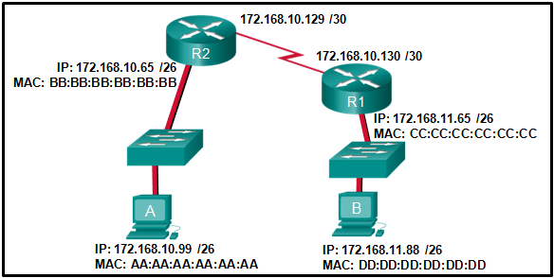

* DD:DD:DD:DD:DD:DD
* 172.168.10.99
* CC:CC:CC:CC:CC:CC
* 172.168.10.65
* **BB:BB:BB:BB:BB:BB**
* AA:AA:AA:AA:AA:AA

**Explain:**  
When a host sends information to a distant network, the Layer 2 frame header will contain a source and destination MAC address. The source address will be the originating host device. The destination address will be the router interface that connects to the same network. In the case of host A sending information to host B, the source address is AA:AA:AA:AA:AA:AA and the destination address is the MAC address assigned to the R2 Ethernet interface, BB:BB:BB:BB:BB:BB.

**6. When a switch configuration includes a user-defined error threshold on a per-port basis, to which switching method will the switch revert when the error threshold is reached?**

* cut-through
* **store-and-forward**
* fast-forward
* fragment-free

**7. Which two statements are correct about MAC and IP addresses during data transmission if NAT is not involved? (Choose two.)**

* **Destination IP addresses in a packet header remain constant along the entire path to a target host.**
* Destination MAC addresses will never change in a frame that goes across seven routers.
* Every time a frame is encapsulated with a new destination MAC address, a new destination IP address is needed.
* **Destination and source MAC addresses have local significance and change every time a frame goes from one LAN to another.**
* A packet that has crossed four routers has changed the destination IP address four times.

**8. What is one main characteristic of the data link layer?**

* It generates the electrical or optical signals that represent the 1 and 0 on the media.
* It converts a stream of data bits into a predefined code.
* **It shields the upper layer protocol from being aware of the physical medium to be used in the communication.**
* It accepts Layer 3 packets and decides the path by which to forward the packet to a remote network.

**9. What are three characteristics of the CSMA/CD process? (Choose three.)**

* The device with the electronic token is the only one that can transmit after a collision.
* **A device listens and waits until the media is not busy before transmitting.**
* **After detecting a collision, hosts can attempt to resume transmission after a random time delay has expired.**
* **All of the devices on a segment see data that passes on the network medium.**
* A jam signal indicates that the collision has cleared and the media is not busy.
* Devices can be configured with a higher transmission priority.

**10. What are two primary responsibilities of the Ethernet MAC sublayer? (Choose two.)**

* error detection
* frame delimiting
* **accessing the media**
* **data encapsulation**
* logical addressing

**11. Which two commands can be used on a Windows host to display the routing table? (Choose two.)**

* netstat -s
* **route print**
* show ip route
* **netstat -r**
* tracert

**Explain:**  
On a Windows host, the route print or netstat -r commands can be used to display the host routing table. Both commands generate the same output. On a router, the show ip route command is used to display the routing table. The netstat –s command is used to display per-protocol statistics. The tracert command is used to display the path that a packet travels to its destination.

**12. What are two functions that are provided by the network layer? (Choose two.)**

* **directing data packets to destination hosts on other networks**
* placing data on the network medium
* carrying data between processes that are running on source and destination hosts
* providing dedicated end-to-end connections
* **providing end devices with a unique network identifier**

**13. Which two statements describe features of an IPv4 routing table on a router? (Choose two.)​**

* **Directly connected interfaces will have two route source codes in the routing table: C and S.**
* If there are two or more possible routes to the same destination, the route associated with the higher metric value is included in the routing table.
* The netstat -r command can be used to display the routing table of a router.​
* The routing table lists the MAC addresses of each active interface.
* It stores information about routes derived from the active router interfaces.
* **If a default static route is configured in the router, an entry will be included in the routing table with source code S.**

**14. How does the service password-encryption command enhance password security on Cisco routers and switches?**

* It requires encrypted passwords to be used when connecting remotely to a router or switch with Telnet.
* **It encrypts passwords that are stored in router or switch configuration files.**
* It requires that a user type encrypted passwords to gain console access to a router or switch.
* It encrypts passwords as they are sent across the network.

**Explain:** The service password-encryption command encrypts plaintext passwords in the configuration file so that they cannot be viewed by unauthorized users.

**15. Why would a Layer 2 switch need an IP address?**

* to enable the switch to send broadcast frames to attached PCs
* to enable the switch to function as a default gateway
* **to enable the switch to be managed remotely**
* to enable the switch to receive frames from attached PCs

**Explanation:** A switch, as a Layer 2 device, does not need an IP address to transmit frames to attached devices. However, when a switch is accessed remotely through the network, it must have a Layer 3 address. The IP address must be applied to a virtual interface rather than to a physical interface. Routers, not switches, function as default gateways.

**16. What characteristic describes identity theft?**

* **the use of stolen credentials to access private data**
* software on a router that filters traffic based on IP addresses or applications
* software that identifies fast-spreading threats
* a tunneling protocol that provides remote users with secure access into the network of an organization

**17. Match each description to its corresponding term. (Not all options are used.)**  
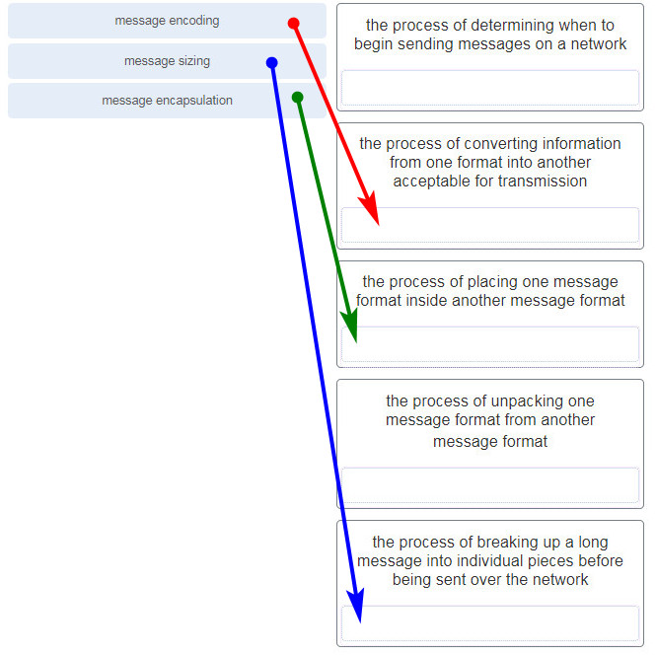

**18. A user sends an HTTP request to a web server on a remote network. During encapsulation for this request, what information is added to the address field of a frame to indicate the destination?**

* the network domain of the destination host
* the IP address of the default gateway
* the MAC address of the destination host
* **the MAC address of the default gateway**

**19. Data is being sent from a source PC to a destination server. Which three statements correctly describe the function of TCP or UDP in this situation? (Choose three.)**

* **The source port field identifies the running application or service that will handle data returning to the PC.**
* The TCP process running on the PC randomly selects the destination port when establishing a session with the server.
* **UDP segments are encapsulated within IP packets for transport across the network.**
* **The UDP destination port number identifies the application or service on the server which will handle the data.**
* TCP is the preferred protocol when a function requires lower network overhead.
* The TCP source port number identifies the sending host on the network.

**Explanation:** Layer 4 port numbers identify the application or service which will handle the data. The source port number is added by the sending device and will be the destination port number when the requested information is returned. Layer 4 segments are encapsulated within IP packets. UDP, not TCP, is used when low overhead is needed. A source IP address, not a TCP source port number, identifies the sending host on the network. Destination port numbers are specific ports that a server application or service monitors for requests.

**20. Match each description with the corresponding TCP mechanism. (Not all options are used.)**  
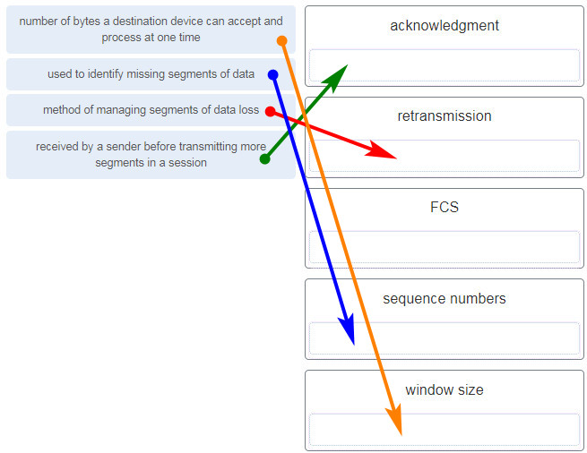

**21. Refer to the exhibit. Which two network addresses can be assigned to the network containing 10 hosts? Your answers should waste the fewest addresses, not reuse addresses that are already assigned, and stay within the 10.18.10.0/24 range of addresses. (Choose two.)**

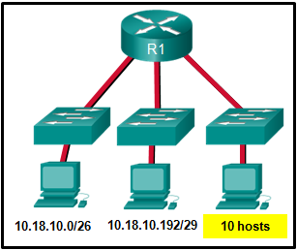

* 10.18.10.200/28
* **10.18.10.208/28**
* 10.18.10.240/27
* 10.18.10.200/27
* 10.18.10.224/27
* **10.18.10.224/28**

**Explanation:** Addresses 10.18.10.0 through 10.18.10.63 are taken for the leftmost network. Addresses 192 through 199 are used by the center network. Because 4 host bits are needed to accommodate 10 hosts, a /28 mask is needed. 10.18.10.200/28 is not a valid network number. Two subnets that can be used are 10.18.10.208/28 and 10.18.10.224/28.

**22. Refer to the exhibit. A company uses the address block of 128.107.0.0/16 for its network. What subnet mask would provide the maximum number of equal size subnets while providing enough host addresses for each subnet in the exhibit?**

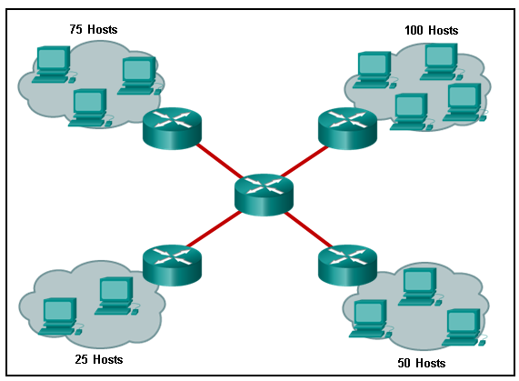

* 255.255.255.192
* 255.255.255.0
* **255.255.255.128**
* 255.255.255.240
* 255.255.255.224

**Explanation:** The largest subnet in the topology has 100 hosts in it so the subnet mask must have at least 7 host bits in it (27-2=126). 255.255.255.0 has 8 hosts bits, but this does not meet the requirement of providing the maximum number of subnets.

**23. A network administrator wants to have the same subnet mask for three subnetworks at a small site. The site has the following networks and numbers of devices:**

Subnetwork A: IP phones – 10 addresses

Subnetwork B: PCs – 8 addresses

Subnetwork C: Printers – 2 addresses

**What single subnet mask would be appropriate to use for the three subnetworks?**

* 255.255.255.0
* **255.255.255.240**
* 255.255.255.248
* 255.255.255.252

**Explain:**  
If the same mask is to be used, then the network with the most hosts must be examined for number of hosts. Because this is 10 hosts, 4 host bits are needed. The /28 or 255.255.255.240 subnet mask would be appropriate to use for these networks. ​

**24. Match each item to the type of topology diagram on which it is typically identified. (Not all options are used.)**  
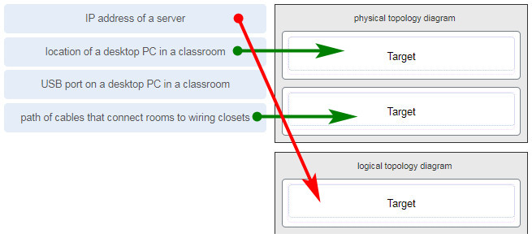

**25. What two pieces of information are displayed in the output of the show ip interface brief command? (Choose two.)**

* **IP addresses**
* interface descriptions
* MAC addresses
* next-hop addresses
* **Layer 1 statuses**
* speed and duplex settings

**Explanation:** The command show ip interface brief shows the IP address of each interface, as well as the operational status of the interfaces at both Layer 1 and Layer 2. In order to see interface descriptions and speed and duplex settings, use the command show running-config interface. Next-hop addresses are displayed in the routing table with the command show ip route, and the MAC address of an interface can be seen with the command show interfaces.

**26. A user is complaining that an external web page is taking longer than normal to load.The web page does eventually load on the user machine. Which tool should the technician use with administrator privileges in order to locate where the issue is in the network?**

* ping
* nslookup
* **tracert**
* ipconfig /displaydns

**27. A network technician is researching the use of fiber optic cabling in a new technology center. Which two issues should be considered before implementing fiber optic media? (Choose two.)**

* **Fiber optic cabling requires different termination and splicing expertise from what copper cabling requires.**
* Fiber optic cabling requires specific grounding to be immune to EMI.
* Fiber optic cabling is susceptible to loss of signal due to RFI.
* Fiber optic cable is able to withstand rough handling.
* **Fiber optic provides higher data capacity but is more expensive than copper cabling.**

**28. What technique is used with UTP cable to help protect against signal interference from crosstalk?**

* wrapping a foil shield around the wire pairs
* **twisting the wires together into pairs**
* terminating the cable with special grounded connectors
* encasing the cables within a flexible plastic sheath

**Explanation:** To help prevent the effects of crosstalk, UTP cable wires are twisted together into pairs. Twisting the wires together causes the magnetic fields of each wire to cancel each other out.

**29. A network administrator is designing the layout of a new wireless network. Which three areas of concern should be accounted for when building a wireless network? (Choose three.)**

* extensive cabling
* mobility options
* packet collision
* **interference**
* **security**
* **coverage area**

**Explanation:** The three areas of concern for wireless networks focus on the size of the coverage area, any nearby interference, and providing network security. Extensive cabling is not a concern for wireless networks, as a wireless network will require minimal cabling for providing wireless access to hosts. Mobility options are not a component of the areas of concern for wireless networks.

**30. Match each description with an appropriate IP address. (Not all options are used.)**  
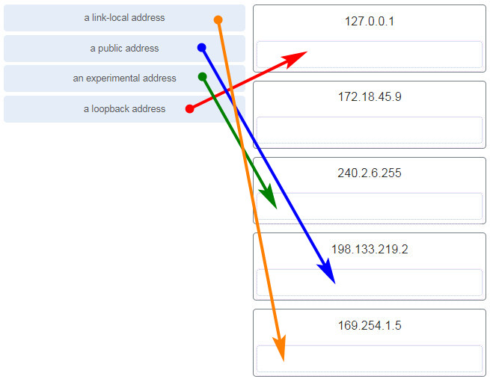

**31. Users report that the network access is slow. After questioning the employees, the network administrator learned that one employee downloaded a third-party scanning program for the printer. What type of malware might be introduced that causes slow performance of the network?**

* virus
* **worm**
* phishing
* spam

**Explanation:** A cybersecurity specialist needs to be familiar with the characteristics of the different types of malware and attacks that threaten an organization.

**32. Which scenario describes a function provided by the transport layer?**

* A student is using a classroom VoIP phone to call home. The unique identifier burned into the phone is a transport layer address used to contact another network device on the same network.
* A student is playing a short web-based movie with sound. The movie and sound are encoded within the transport layer header.
* **A student has two web browser windows open in order to access two web sites. The transport layer ensures the correct web page is delivered to the correct browser window.**
* A corporate worker is accessing a web server located on a corporate network. The transport layer formats the screen so the web page appears properly no matter what device is being used to view the web site.

**Explain:**  
The source and destination port numbers are used to identify the correct application and window within that application.

**33.Refer to the exhibit. Host B on subnet Teachers transmits a packet to host D on subnet Students. Which Layer 2 and Layer 3 addresses are contained in the PDUs that are transmitted from host B to the router?**  
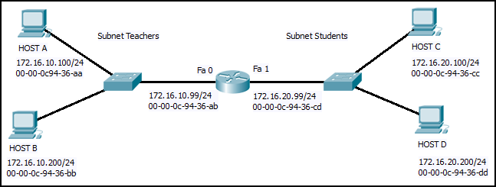  
**Layer 2 destination address = 00-00-0c-94-36-ab  
Layer 2 source address = 00-00-0c-94-36-bb  
Layer 3 destination address = 172.16.20.200  
Layer 3 source address = 172.16.10.200**

Layer 2 destination address = 00-00-0c-94-36-dd  
Layer 2 source address = 00-00-0c-94-36-bb  
Layer 3 destination address = 172.16.20.200  
Layer 3 source address = 172.16.10.200

Layer 2 destination address = 00-00-0c-94-36-cd  
Layer 2 source address = 00-00-0c-94-36-bb  
Layer 3 destination address = 172.16.20.99  
Layer 3 source address = 172.16.10.200

Layer 2 destination address = 00-00-0c-94-36-ab  
Layer 2 source address = 00-00-0c-94-36-bb  
Layer 3 destination address = 172.16.20.200  
Layer 3 source address = 172.16.100.200

**34. What does the term “attenuation” mean in data communication?**

* strengthening of a signal by a networking device
* leakage of signals from one cable pair to another
* time for a signal to reach its destination
* **loss of signal strength as distance increases**

**35. Refer to the exhibit. An administrator is trying to configure the switch but receives the error message that is displayed in the exhibit. What is the problem?**  


* The entire command, configure terminal, must be used.
* The administrator is already in global configuration mode.
* **The administrator must first enter privileged EXEC mode before issuing the command.**
* The administrator must connect via the console port to access global configuration mode.

**36. Which two protocols operate at the top layer of the TCP/IP protocol suite? (Choose two.)**

* TCP
* IP
* UDP
* **POP**
* **DNS**
* Ethernet

**37. A company has a file server that shares a folder named Public. The network security policy specifies that the Public folder is assigned Read-Only rights to anyone who can log into the server while the Edit rights are assigned only to the network admin group. Which component is addressed in the AAA network service framework?**

* automation
* accounting
* authentication
* **authorization**

After a user is successfully authenticated (logged into the server), the authorization is the process of determining what network resources the user can access and what operations (such as read or edit) the user can perform.

**38. What three requirements are defined by the protocols used in network communcations to allow message transmission across a network? (Choose three.)**

* **message size**
* **message encoding**
* connector specifications
* media selection
* **delivery options**
* end-device installation

**39. What are two characteristics of IP? (Choose two.)**

* **does not require a dedicated end-to-end connection**
* **operates independently of the network media**
* retransmits packets if errors occur
* re-assembles out of order packets into the correct order at the receiver end
* guarantees delivery of packets

**Explain:**  
The Internet Protocol (IP) is a connectionless, best effort protocol. This means that IP requires no end-to-end connection nor does it guarantee delivery of packets. IP is also media independent, which means it operates independently of the network media carrying the packets.

**40. An employee of a large corporation remotely logs into the company using the appropriate username and password. The employee is attending an important video conference with a customer concerning a large sale. It is important for the video quality to be excellent during the meeting. The employee is unaware that after a successful login, the connection to the company ISP failed. The secondary connection, however, activated within seconds. The disruption was not noticed by the employee or other employees. What three network characteristics are described in this scenario? (Choose three.)**

* **security**
* **quality of service**
* scalability
* powerline networking
* integrity
* **fault tolerance**

**41. What are two common causes of signal degradation when using UTP cabling? (Choose two.)**

* **improper termination**
* low-quality shielding in cable
* installing cables in conduit
* **low-quality cable or connectors**
* loss of light over long distances

**42. Which subnet would include the address 192.168.1.96 as a usable host address?**

* **192.168.1.64/26**
* 192.168.1.32/27
* 192.168.1.32/28
* 192.168.1.64/29

**Explanation:** For the subnet of 192.168.1.64/26, there are 6 bits for host addresses, yielding 64 possible addresses. However, the first and last subnets are the network and broadcast addresses for this subnet. Therefore, the range of host addresses for this subnet is 192.168.1.65 to 192.168.1.126. The other subnets do not contain the address 192.168.1.96 as a valid host address.

**43. Refer to the exhibit. On the basis of the output, which two statements about network connectivity are correct? (Choose two.)**  
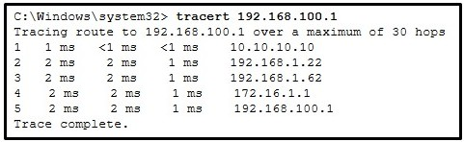

* This host does not have a default gateway configured.
* **There are 4 hops between this device and the device at 192.168.100.1.**
* **There is connectivity between this device and the device at 192.168.100.1.**
* The connectivity between these two hosts allows for videoconferencing calls.
* The average transmission time between the two hosts is 2 milliseconds.

**Explain:**  
The output displays a successful Layer 3 connection between a host computer and a host at 19.168.100.1. It can be determined that 4 hops exist between them and the average transmission time is 1 milliseconds. Layer 3 connectivity does not necessarily mean that an application can run between the hosts.

**44. Which two statements describe how to assess traffic flow patterns and network traffic types using a protocol analyzer? (Choose two.)**

* Capture traffic on the weekends when most employees are off work.
* **Capture traffic during peak utilization times to get a good representation of the different traffic types.**
* Only capture traffic in the areas of the network that receive most of the traffic such as the data center.
* **Perform the capture on different network segments.**
* Only capture WAN traffic because traffic to the web is responsible for the largest amount of traffic on a network.

**Explanation:** Traffic flow patterns should be gathered during peak utilization times to get a good representation of the different traffic types. The capture should also be performed on different network segments because some traffic will be local to a particular segment.

**45. What is the consequence of configuring a router with the *ipv6 unicast-routing*global configuration command?​**

* All router interfaces will be automatically activated.
* **The IPv6 enabled router interfaces begin sending ICMPv6 Router Advertisement messages.**
* Each router interface will generate an IPv6 link-local address.​
* It statically creates a global unicast address on this router.​

**46. Which three layers of the OSI model map to the application layer of the TCP/IP model? (Choose three.)**

* **application**
* network
* data link
* **session**
* **presentation**
* transport

**Explanation:** The TCP/IP model consists of four layers: application, transport, internet, and network access. The OSI model consists of seven layers: application, presentation, session, transport, network, data link, and physical. The top three layers of the OSI model: application, presentation, and session map to the application layer of the TCP/IP model.

**47. Refer to the exhibit. If PC1 is sending a packet to PC2 and routing has been configured between the two routers, what will R1 do with the Ethernet frame header attached by PC1?**

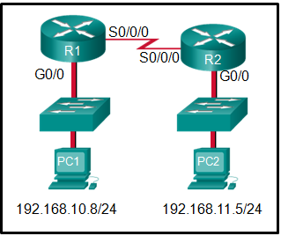

* nothing, because the router has a route to the destination network
* open the header and use it to determine whether the data is to be sent out S0/0/0
* open the header and replace the destination MAC address with a new one
* **remove the Ethernet header and configure a new Layer 2 header before sending it out S0/0/0**

**Explanation:** When PC1 forms the various headers attached to the data one of those headers is the Layer 2 header. Because PC1 connects to an Ethernet network, an Ethernet header is used. The source MAC address will be the MAC address of PC1 and the destination MAC address will be that of G0/0 on R1. When R1 gets that information, the router removes the Layer 2 header and creates a new one for the type of network the data will be placed onto (the serial link).

**48. What will happen if the default gateway address is incorrectly configured on a host?**

* The host cannot communicate with other hosts in the local network.
* **The host cannot communicate with hosts in other networks.**
* A ping from the host to 127.0.0.1 would not be successful.
* The host will have to use ARP to determine the correct address of the default gateway.
* The switch will not forward packets initiated by the host.

**49. What are two features of ARP? (Choose two.)**

* When a host is encapsulating a packet into a frame, it refers to the MAC address table to determine the mapping of IP addresses to MAC addresses.
* An ARP request is sent to all devices on the Ethernet LAN and contains the IP address of the destination host and its multicast MAC address.
* **If a host is ready to send a packet to a local destination device and it has the IP address but not the MAC address of the destination, it generates an ARP broadcast.**
* If no device responds to the ARP request, then the originating node will broadcast the data packet to all devices on the network segment.
* **If a device receiving an ARP request has the destination IPv4 address, it responds with an ARP reply.**

**50. A network administrator is adding a new LAN to a branch office. The new LAN must support 90 connected devices. What is the smallest network mask that the network administrator can use for the new network?**

* **255.255.255.128**
* 255.255.255.240
* 255.255.255.248
* 255.255.255.224

**51. What are two ICMPv6 messages that are not present in ICMP for IPv4? (Choose two.)**

* **Neighbor Solicitation**
* Destination Unreachable
* Host Confirmation
* Time Exceeded
* **Router Advertisement**
* Route Redirection

**52. A client packet is received by a server. The packet has a destination port number of 80. What service is the client requesting?**

* DHCP
* SMTP
* DNS
* **HTTP**

**53. What is an advantage for small organizations of adopting IMAP instead of POP?**

* POP only allows the client to store messages in a centralized way, while IMAP allows distributed storage.
* **Messages are kept in the mail servers until they are manually deleted from the email client.**
* When the user connects to a POP server, copies of the messages are kept in the mail server for a short time, but IMAP keeps them for a long time.
* IMAP sends and retrieves email, but POP only retrieves email.

**Explanation:** IMAP and POP are protocols that are used to retrieve email messages. The advantage of using IMAP instead of POP is that when the user connects to an IMAP-capable server, copies of the messages are downloaded to the client application. IMAP then stores the email messages on the server until the user manually deletes those messages.

**54. A technician can ping the IP address of the web server of a remote company but cannot successfully ping the URL address of the same web server. Which software utility can the technician use to diagnose the problem?**

* tracert
* ipconfig
* netstat
* **nslookup**

**Explain:**  
Traceroute (tracert) is a utility that generates a list of hops that were successfully reached along the path from source to destination.This list can provide important verification and troubleshooting information. The ipconfig utility is used to display the IP configuration settings on a Windows PC. The Netstat utility is used to identify which active TCP connections are open and running on a networked host. Nslookup is a utility that allows the user to manually query the name servers to resolve a given host name. This utility can also be used to troubleshoot name resolution issues and to verify the current status of the name servers.

**55. Which two functions are performed at the LLC sublayer of the OSI Data Link Layer to facilitate Ethernet communication? (Choose two.)**

* implements CSMA/CD over legacy shared half-duplex media
* **enables IPv4 and IPv6 to utilize the same physical medium**
* integrates Layer 2 flows between 10 Gigabit Ethernet over fiber and 1 Gigabit Ethernet over copper
* implements a process to delimit fields within an Ethernet 2 frame
* **places information in the Ethernet frame that identifies which network layer protocol is being encapsulated by the frame**

**Explanation:** The data link layer is actually divided into two sublayers:

+ Logical Link Control (LLC): This upper sublayer defines the software processes that provide services to the network layer protocols. It places information in the frame that identifies which network layer protocol is being used for the frame. This information allows multiple Layer 3 protocols, such as IPv4 and IPv6, to utilize the same network interface and media.  
+ Media Access Control (MAC): This lower sublayer defines the media access processes performed by the hardware. It provides data link layer addressing and delimiting of data according to the physical signaling requirements of the medium and the type of data link layer protocol in use.

**56. The global configuration command *ip default-gateway 172.16.100.1*is applied to a switch. What is the effect of this command?**

* The switch can communicate with other hosts on the 172.16.100.0 network.
* **The switch can be remotely managed from a host on another network.**
* The switch is limited to sending and receiving frames to and from the gateway 172.16.100.1.
* The switch will have a management interface with the address 172.16.100.1.

**Explanation:** A default gateway address is typically configured on all devices to allow them to communicate beyond just their local network.In a switch this is achieved using the command ip default-gateway .

**57. What happens when the *transport input ssh*command is entered on the switch vty lines?**

* The SSH client on the switch is enabled.
* The switch requires a username/password combination for remote access.
* **Communication between the switch and remote users is encrypted.**
* The switch requires remote connections via a proprietary client software.

**Explanation:** The **transport input ssh** command when entered on the switch vty (virtual terminal lines) will encrypt all inbound controlled telnet connections.

**58. Match the type of threat with the cause. (Not all options are used.)**  
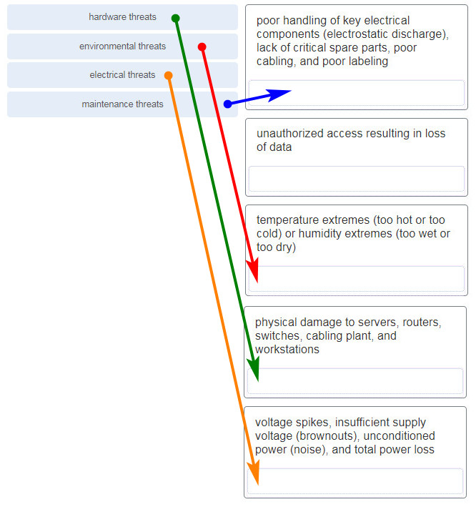

**59. A disgruntled employee is using some free wireless networking tools to determine information about the enterprise wireless networks. This person is planning on using this information to hack the wireless network. What type of attack is this?**

* DoS
* access
* **reconnaissance**
* Trojan horse

**60. What service is provided by HTTP?**

* Uses encryption to secure the exchange of text, graphic images, sound, and video on the web.
* Allows for data transfers between a client and a file server.
* An application that allows real-time chatting among remote users.
* **A basic set of rules for exchanging text, graphic images, sound, video, and other multimedia files on the web.**

**61. A client packet is received by a server. The packet has a destination port number of 67. What service is the client requesting?**

* FTP
* **DHCP**
* Telnet
* SSH

**62. What are two problems that can be caused by a large number of ARP request and reply messages? (Choose two.)**

* Switches become overloaded because they concentrate all the traffic from the attached subnets.
* **The ARP request is sent as a broadcast, and will flood the entire subnet.**
* The network may become overloaded because ARP reply messages have a very large payload due to the 48-bit MAC address and 32-bit IP address that they contain.
* A large number of ARP request and reply messages may slow down the switching process, leading the switch to make many changes in its MAC table.
* **All ARP request messages must be processed by all nodes on the local network.**

**Explanation:** ARP requests are sent as broadcasts:  
(1) All nodes will receive them, and they will be processed by software, interrupting the CPU.  
(2) The switch forwards (floods) Layer 2 broadcasts to all ports.

A switch does not change its MAC table based on ARP request or reply messages. The switch populates the MAC table using the source MAC address of all frames. The ARP payload is very small and does not overload the switch.

**63. A group of Windows PCs in a new subnet has been added to an Ethernet network. When testing the connectivity, a technician finds that these PCs can access local network resources but not the Internet resources. To troubleshoot the problem, the technician wants to initially confirm the IP address and DNS configurations on the PCs, and also verify connectivity to the local router. Which three Windows CLI commands and utilities will provide the necessary information? (Choose three.)**

* netsh interface ipv6 show neighbor
* arp -a
* tracert
* **ping**
* **ipconfig**
* **nslookup**
* telnet

**64. During the process of forwarding traffic, what will the router do immediately after matching the destination IP address to a network on a directly connected routing table entry?**

* analyze the destination IP address
* **switch the packet to the directly connected interface**
* look up the next-hop address for the packet
* discard the traffic after consulting the route table

**65. What characteristic describes antispyware?**

* **applications that protect end devices from becoming infected with malicious software**
* a network device that filters access and traffic coming into a network
* software on a router that filters traffic based on IP addresses or applications
* a tunneling protocol that provides remote users with secure access into the network of an organization

**66. A network administrator needs to keep the user ID, password, and session contents private when establishing remote CLI connectivity with a switch to manage it. Which access method should be chosen?**

* Telnet
* AUX
* **SSH**
* Console

**67. What are the two most effective ways to defend against malware? (Choose two.)**

* Implement a VPN.
* Implement network firewalls.
* Implement RAID.
* Implement strong passwords.
* **Update the operating system and other application software.**
* **Install and update antivirus software.**

**Explanation:** A cybersecurity specialist must be aware of the technologies and measures that are used as countermeasures to protect the organization from threats and vulnerabilities.

**68. Which type of security threat would be responsible if a spreadsheet add-on disables the local software firewall?**

* brute-force attack
* **Trojan horse**
* DoS
* buffer overflow

**Explanation:** A Trojan horse is software that does something harmful, but is hidden in legitimate software code. A denial of service (DoS) attack results in interruption of network services to users, network devices, or applications. A brute-force attack commonly involves trying to access a network device. A buffer overflow occurs when a program attempts to store more data in a memory location than it can hold.

**69. Match the header field with the appropriate layer of the OSI model. (Not all options are used.)**  
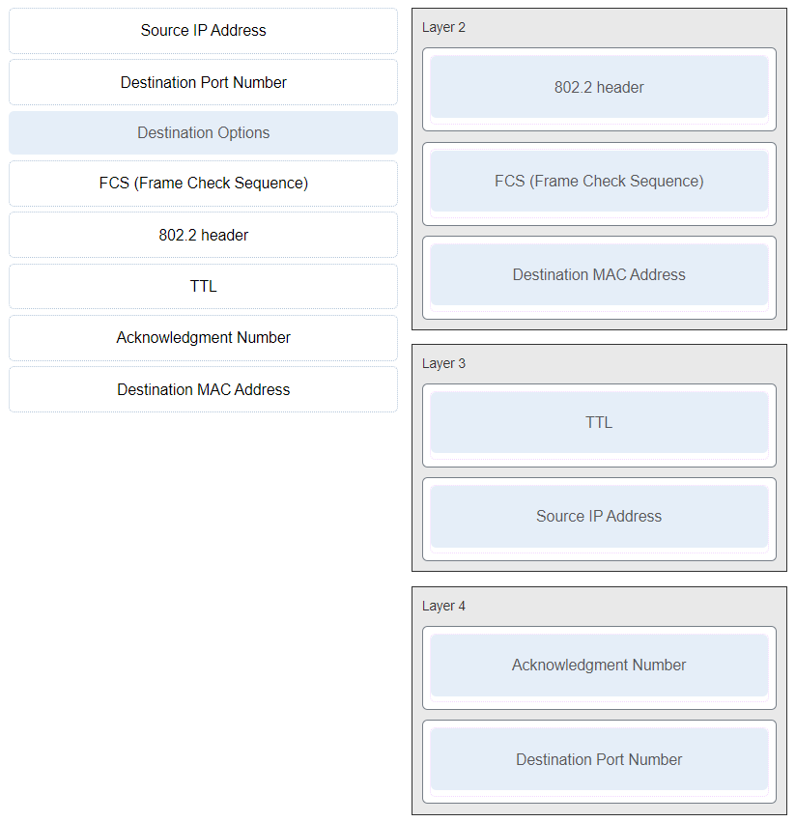

**70. Which frame field is created by a source node and used by a destination node to ensure that a transmitted data signal has not been altered by interference, distortion, or signal loss?**

* User Datagram Protocol field
* transport layer error check field
* flow control field
* **frame check sequence field**
* error correction process field

**71. A network administrator is adding a new LAN to a branch office. The new LAN must support 4 connected devices. What is the smallest network mask that the network administrator can use for the new network?**

* **255.255.255.248**
* 255.255.255.0
* 255.255.255.128
* 255.255.255.192

**72. What service is provided by POP3?**

* **Retrieves email from the server by downloading the email to the local mail application of the client.**
* An application that allows real-time chatting among remote users.
* Allows remote access to network devices and servers.
* Uses encryption to provide secure remote access to network devices and servers.

**73. What two security solutions are most likely to be used only in a corporate environment? (Choose two.)**

* antispyware
* **virtual private networks**
* **intrusion prevention systems**
* strong passwords
* antivirus software

**74. What characteristic describes antivirus software?**

* **applications that protect end devices from becoming infected with malicious software**
* a network device that filters access and traffic coming into a network
* a tunneling protocol that provides remote users with secure access into the network of an organization
* software on a router that filters traffic based on IP addresses or applications

**75. What mechanism is used by a router to prevent a received IPv4 packet from traveling endlessly on a network?**

* It checks the value of the TTL field and if it is 0, it discards the packet and sends a Destination Unreachable message to the source host.
* It checks the value of the TTL field and if it is 100, it discards the packet and sends a Destination Unreachable message to the source host.
* **It decrements the value of the TTL field by 1 and if the result is 0, it discards the packet and sends a Time Exceeded message to the source host.**
* It increments the value of the TTL field by 1 and if the result is 100, it discards the packet and sends a Parameter Problem message to the source host.

**76. A client packet is received by a server. The packet has a destination port number of 69. What service is the client requesting?**

* DNS
* DHCP
* SMTP
* **TFTP**

**77. An administrator defined a local user account with a secret password on router R1 for use with SSH. Which three additional steps are required to configure R1 to accept only encrypted SSH connections? (Choose three.)**

* Configure DNS on the router.
* Generate two-way pre-shared keys.
* **Configure the IP domain name on the router.**
* **Generate the SSH keys.**
* **Enable inbound vty SSH sessions.**
* Enable inbound vty Telnet sessions.

**78. Which two functions are performed at the MAC sublayer of the OSI Data Link Layer to facilitate Ethernet communication? (Choose two.)**

* **places information in the Ethernet frame that identifies which network layer protocol is being encapsulated by the frame**
* adds Ethernet control information to network protocol data
* responsible for internal structure of Ethernet frame
* enables IPv4 and IPv6 to utilize the same physical medium
* **implements trailer with frame check sequence for error detection**

**79. An IPv6 enabled device sends a data packet with the destination address of FF02::2. What is the target of this packet?​**

* all IPv6 enabled devices on the local link​
* all IPv6 DHCP servers​
* all IPv6 enabled devices across the network​
* **all IPv6 configured routers on the local link​**

**80. What are the three parts of an IPv6 global unicast address? (Choose three.)**

* **subnet ID**
* subnet mask
* broadcast address
* **global routing prefix**
* **interface ID**

**81. A client is using SLAAC to obtain an IPv6 address for its interface. After an address has been generated and applied to the interface, what must the client do before it can begin to use this IPv6 address?**

* It must send a DHCPv6 INFORMATION-REQUEST message to request the address of the DNS server.
* It must send a DHCPv6 REQUEST message to the DHCPv6 server to request permission to use this address.
* It must send an ICMPv6 Router Solicitation message to determine what default gateway it should use.
* **It must send an ICMPv6 Neighbor Solicitation message to ensure that the address is not already in use on the network.**

**82. A new network administrator has been asked to enter a banner message on a Cisco device. What is the fastest way a network administrator could test whether the banner is properly configured?**

* Enter CTRL-Z at the privileged mode prompt.
* Exit global configuration mode.
* Power cycle the device.
* Reboot the device.
* **Exit privileged EXEC mode and press Enter .**

**83. What method is used to manage contention-based access on a wireless network?**

* token passing
* **CSMA/CA**
* priority ordering
* CSMA/CD

**84. What is a function of the data link layer?**

* provides the formatting of data
* provides end-to-end delivery of data between hosts
* provides delivery of data between two applications
* **provides for the exchange of frames over a common local media**

**85. What is the purpose of the TCP sliding window?**

* to ensure that segments arrive in order at the destination
* to end communication when data transmission is complete
* to inform a source to retransmit data from a specific point forward
* **to request that a source decrease the rate at which it transmits data**

**86. What characteristic describes spyware?**

* a network device that filters access and traffic coming into a network
* **software that is installed on a user device and collects information about the user**
* an attack that slows or crashes a device or network service
* the use of stolen credentials to access private data

**87. Which switching method drops frames that fail the FCS check?**

* **store-and-forward switching**
* borderless switching
* ingress port buffering
* cut-through switching

**88. Two pings were issued from a host on a local network. The first ping was issued to the IP address of the default gateway of the host and it failed. The second ping was issued to the IP address of a host outside the local network and it was successful. What is a possible cause for the failed ping?**

* The default gateway is not operational.
* The default gateway device is configured with the wrong IP address.
* **Security rules are applied to the default gateway device, preventing it from processing ping requests.**
* The TCP/IP stack on the default gateway is not working properly.

**89. What service is provided by FTP?**

* A basic set of rules for exchanging text, graphic images, sound, video, and other multimedia files on the web.
* An application that allows real-time chatting among remote users.
* **Allows for data transfers between a client and a file server.**
* Uses encryption to secure the exchange of text, graphic images, sound, and video on the web.

**90. A user is attempting to access http://www.cisco.com/ without success. Which two configuration values must be set on the host to allow this access? (Choose two.)**

* **DNS server**
* source port number
* HTTP server
* source MAC address
* **default gateway**

**91. Which two statements accurately describe an advantage or a disadvantage when deploying NAT for IPv4 in a network? (Choose two.)**

* NAT adds authentication capability to IPv4.
* **NAT introduces problems for some applications that require end-to-end connectivity.**
* NAT will impact negatively on switch performance.
* **NAT provides a solution to slow down the IPv4 address depletion.**
* NAT improves packet handling.
* NAT causes routing tables to include more information.

**92. What subnet mask is needed if an IPv4 network has 40 devices that need IP addresses and address space is not to be wasted?**

* 255.255.255.0
* 255.255.255.240
* 255.255.255.128
* **255.255.255.192**
* 255.255.255.224

**93. Refer to the exhibit. PC1 issues an ARP request because it needs to send a packet to PC2. In this scenario, what will happen next?**  
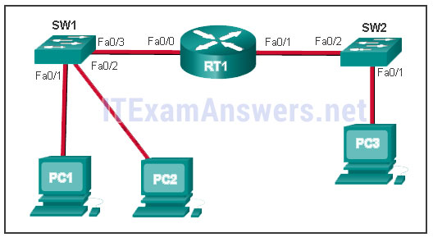

* **PC2 will send an ARP reply with its MAC address.**
* RT1 will send an ARP reply with its Fa0/0 MAC address.
* RT1 will send an ARP reply with the PC2 MAC address.
* SW1 will send an ARP reply with the PC2 MAC address.
* SW1 will send an ARP reply with its Fa0/1 MAC address.

**Explain:**  
When a network device wants to communicate with another device on the same network, it sends a broadcast ARP request. In this case, the request will contain the IP address of PC2. The destination device (PC2) sends an ARP reply with its MAC address.

**94. What service is provided by BOOTP?**

* Uses encryption to secure the exchange of text, graphic images, sound, and video on the web.
* Allows for data transfers between a client and a file server.
* **Legacy application that enables a diskless workstation to discover its own IP address and find a BOOTP server on the network.**
* A basic set of rules for exchanging text, graphic images, sound, video, and other multimedia files on the web.

**95. What characteristic describes adware?**

* a network device that filters access and traffic coming into a network
* **software that is installed on a user device and collects information about the user**
* the use of stolen credentials to access private data
* an attack that slows or crashes a device or network service

**96. What is a benefit of using cloud computing in networking?**

* Technology is integrated into every-day appliances allowing them to interconnect with other devices, making them more ‘smart’ or automated.
* **Network capabilities are extended without requiring investment in new infrastructure, personnel, or software.**
* End users have the freedom to use personal tools to access information and communicate across a business network.
* Home networking uses existing electrical wiring to connect devices to the network wherever there is an electrical outlet, saving the cost of installing data cables.

**97. Match a statement to the related network model. (Not all options are used.)**  
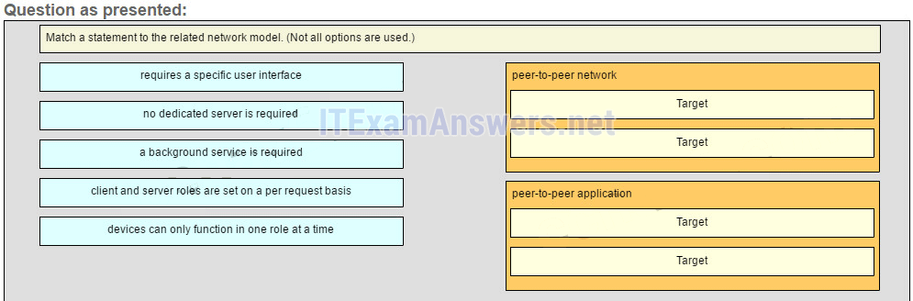  
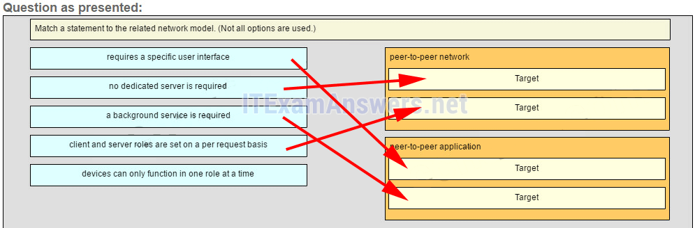  
**Place the options in the following order:peer-to-peer network**  
**[+] no dedicated server is required**  
**[+] client and server roles are set on a per request basis**  
**peer-to-peer aplication**  
**[#] requires a specific user interface**  
**[#] a background service is required**

**Explain:**  
Peer-to-peer networks do not require the use of a dedicated server, and devices can assume both client and server roles simultaneously on a per request basis. Because they do not require formalized accounts or permissions, they are best used in limited situations. Peer-to-peer applications require a user interface and background service to be running, and can be used in more diverse situations.

**98. Which information does the show startup-config command display?**

* the IOS image copied into RAM
* the bootstrap program in the ROM
* the contents of the current running configuration file in the RAM
* **the contents of the saved configuration file in the NVRAM**

**Explain:**  
The show startup-config command displays the saved configuration located in NVRAM. The show running-config command displays the contents of the currently running configuration file located in RAM.​

**99. Refer to the exhibit. What three facts can be determined from the viewable output of the show ip interface brief command? (Choose three.)**  
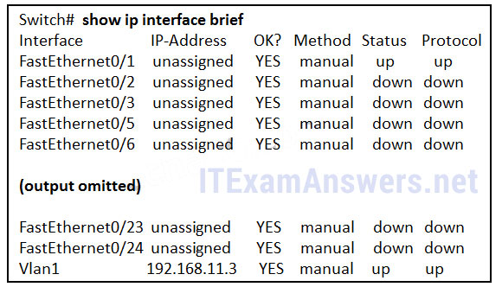

* Two physical interfaces have been configured.
* **The switch can be remotely managed.**
* **One device is attached to a physical interface.**
* Passwords have been configured on the switch.
* Two devices are attached to the switch.
* **The default SVI has been configured.**

**Explain:**  
Vlan1 is the default SVI. Because an SVI has been configured, the switch can be configured and managed remotely. FastEthernet0/0 is showing up and up, so a device is connected.

**100. Match each type of frame field to its function. (Not all options are used.)**  
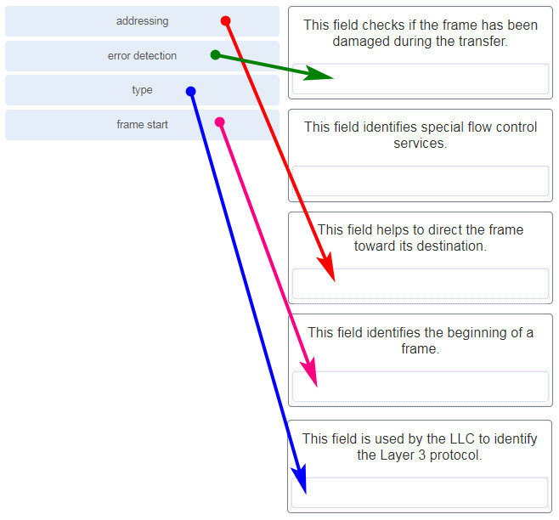

**101. What is the subnet ID associated with the IPv6 address 2001:DA48:FC5:A4:3D1B::1/64?**

* 2001:DA48::/64​
* 2001:DA48:FC5::A4:/64​
* **2001:DA48:FC5:A4::/64​**
* 2001::/64

**102. Match the firewall function to the type of threat protection it provides to the network. (Not all options are used.)**  
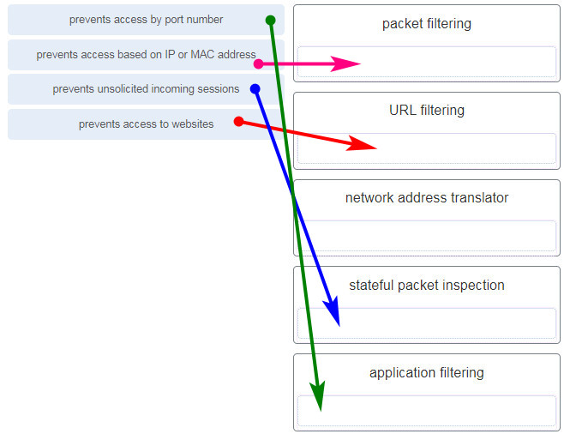

* packet filtering – prevents access based on IP or MAC address
* URL filtering – prevents access to websites
* network address translator – (none)
* stateful packet inspection – prevents unsolicited incoming sessions
* application filtering – prevents access by port number

**Explain:**Firewall products come packaged in various forms. These products use different techniques for determining what will be permitted or denied access to a network. They include the following:

+ Packet filtering – Prevents or allows access based on IP or MAC addresses  
+ Application filtering – Prevents or allows access by specific application types based on port numbers  
+ URL filtering – Prevents or allows access to websites based on specific URLs or keywords  
+ Stateful packet inspection (SPI) – Incoming packets must be legitimate responses to requests from internal hosts. Unsolicited packets are blocked unless permitted specifically. SPI can also include the capability to recognize and filter out specific types of attacks, such as denial of service (DoS)

**103. Users are reporting longer delays in authentication and in accessing network resources during certain time periods of the week. What kind of information should network engineers check to find out if this situation is part of a normal network behavior?**

* syslog records and messages
* **the network performance baseline**
* debug output and packet captures
* network configuration files

**104. What characteristic describes a VPN?**

* software on a router that filters traffic based on IP addresses or applications
* software that identifies fast-spreading threats
* **a tunneling protocol that provides remote users with secure access into the network of an organization**
* a network device that filters access and traffic coming into a network

**105. Which two statements are correct in a comparison of IPv4 and IPv6 packet headers? (Choose two.)**

* **The Source Address field name from IPv4 is kept in IPv6.**
* The Version field from IPv4 is not kept in IPv6.
* The Destination Address field is new in IPv6.
* The Header Checksum field name from IPv4 is kept in IPv6.
* **The Time-to-Live field from IPv4 has been replaced by the Hop Limit field in IPv6.**

**106. A network administrator wants to have the same network mask for all networks at a particular small site. The site has the following networks and number of devices:  
IP phones – 22 addresses  
PCs – 20 addresses needed  
Printers – 2 addresses needed  
Scanners – 2 addresses needed**

The network administrator has deemed that 192.168.10.0/24 is to be the network used at this site. Which single subnet mask would make the most efficient use of the available addresses to use for the four subnetworks?

* 255.255.255.192
* 255.255.255.252
* 255.255.255.240
* 255.255.255.248
* 255.255.255.0
* **255.255.255.224**

**107. What is an advantage to using a protocol that is defined by an open standard?**

* A company can monopolize the market.
* The protocol can only be run on equipment from a specific vendor.
* An open standard protocol is not controlled or regulated by standards organizations.
* **It encourages competition and promotes choices.**

**Explain:**  
A monopoly by one company is not a good idea from a user point of view. If a protocol can only be run on one brand, it makes it difficult to have mixed equipment in a network. A proprietary protocol is not free to use. An open standard protocol will in general be implemented by a wide range of vendors.

**108. A network administrator is adding a new LAN to a branch office. The new LAN must support 200 connected devices. What is the smallest network mask that the network administrator can use for the new network?**

* 255.255.255.240
* **255.255.255.0**
* 255.255.255.248
* 255.255.255.224

**109. What are three commonly followed standards for constructing and installing cabling? (Choose three.)**

* cost per meter (foot)
* **cable lengths**
* connector color
* **pinouts**
* **connector types**
* tensile strength of plastic insulator

**110. Refer to the exhibit. What is wrong with the displayed termination?**



* The woven copper braid should not have been removed.
* The wrong type of connector is being used.
* **The untwisted length of each wire is too long.**
* The wires are too thick for the connector that is used.

**Explanation:** When a cable to an RJ-45 connector is terminated, it is important to ensure that the untwisted wires are not too long and that the flexible plastic sheath surrounding the wires is crimped down and not the bare wires. None of the colored wires should be visible from the bottom of the jack.

**111. Match the characteristic to the category. (Not all options are used.)**  
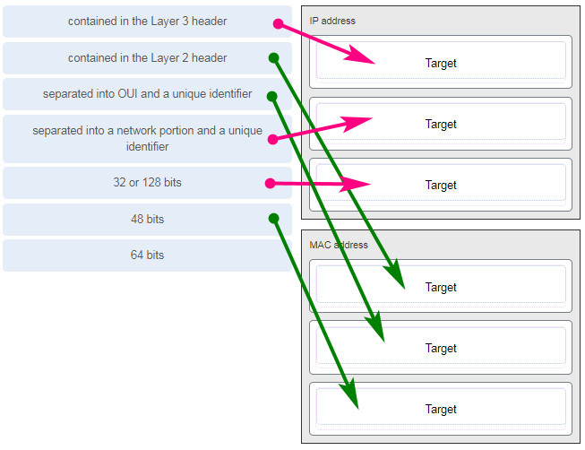

**112. A client packet is received by a server. The packet has a destination port number of 143. What service is the client requesting?**

* **IMAP**
* FTP
* SSH
* Telnet

**113. What are two characteristics shared by TCP and UDP? (Choose two.)**

* default window size
* connectionless communication
* **port numbering**
* 3-way handshake
* ability to to carry digitized voice
* **use of checksum**

**Explain:**  
Both TCP and UDP use source and destination port numbers to distinguish different data streams and to forward the right data segments to the right applications. Error checking the header and data is done by both protocols by using a checksum calculation to determine the integrity of the data that is received. TCP is connection-oriented and uses a 3-way handshake to establish an initial connection. TCP also uses window to regulate the amount of traffic sent before receiving an acknowledgment. UDP is connectionless and is the best protocol for carry digitized VoIP signals.

**114. Which value, that is contained in an IPv4 header field, is decremented by each router that receives a packet?**

* Header Length
* Differentiated Services
* **Time-to-Live**
* Fragment Offset

**Explanation:** When a router receives a packet, the router will decrement the Time-to-Live (TTL) field by one. When the field reaches zero, the receiving router will discard the packet and will send an ICMP Time Exceeded message to the sender.

**115. A client packet is received by a server. The packet has a destination port number of 21. What service is the client requesting?**

* **FTP**
* LDAP
* SLP
* SNMP

**116. What attribute of a NIC would place it at the data link layer of the OSI model?**

* attached Ethernet cable
* IP address
* **MAC address**
* RJ-45 port
* TCP/IP protocol stack

**117. A network administrator is adding a new LAN to a branch office. The new LAN must support 10 connected devices. What is the smallest network mask that the network administrator can use for the new network?**

* 255.255.255.192
* 255.255.255.248
* 255.255.255.224
* **255.255.255.240**

**118. A user is executing a tracert to a remote device. At what point would a router, which is in the path to the destination device, stop forwarding the packet?**

* when the router receives an ICMP Time Exceeded message
* when the RTT value reaches zero
* when the host responds with an ICMP Echo Reply message
* **when the value in the TTL field reaches zero**
* when the values of both the Echo Request and Echo Reply messages reach zero

**Explain:**  
When a router receives a traceroute packet, the value in the TTL field is decremented by 1. When the value in the field reaches zero, the receiving router will not forward the packet, and will send an ICMP Time Exceeded message back to the source.

**119. Refer to the exhibit. The network administrator has assigned the LAN of LBMISS an address range of 192.168.10.0. This address range has been subnetted using a /29 prefix. In order to accommodate a new building, the technician has decided to use the fifth subnet for configuring the new network (subnet zero is the first subnet). By company policies, the router interface is always assigned the first usable host address and the workgroup server is given the last usable host address. Which configuration should be entered into the properties of the workgroup server to allow connectivity to the Internet?**  
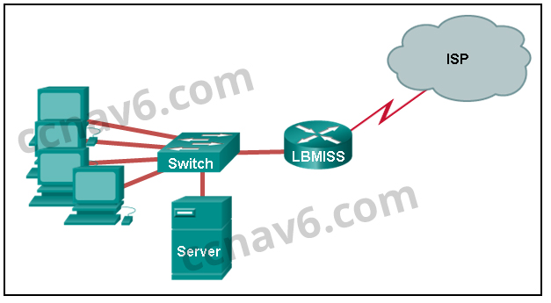

* IP address: 192.168.10.65 subnet mask: 255.255.255.240, default gateway: 192.168.10.76
* IP address: 192.168.10.38 subnet mask: 255.255.255.240, default gateway: 192.168.10.33
* **IP address: 192.168.10.38 subnet mask: 255.255.255.248, default gateway: 192.168.10.33**
* IP address: 192.168.10.41 subnet mask: 255.255.255.248, default gateway: 192.168.10.46
* IP address: 192.168.10.254 subnet mask: 255.255.255.0, default gateway: 192.168.10.1

**Explain:**  
Using a /29 prefix to subnet 192.168.10.0 results in subnets that increment by 8:  
192.168.10.0 (1)  
192.168.10.8 (2)  
192.168.10.16 (3)  
192.168.10.24 (4)  
192.168.10.32 (5)

**120. Refer to the exhibit. The switches are in their default configuration. Host A needs to communicate with host D, but host A does not have the MAC address for its default gateway. Which network hosts will receive the ARP request sent by host A?**  
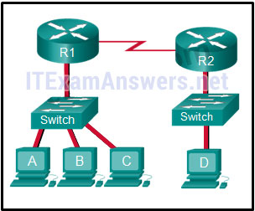

* only host D
* only router R1
* only hosts A, B, and C
* only hosts A, B, C, and D
* only hosts B and C
* **only hosts B, C, and router R1**

**Explain:**  
Since host A does not have the MAC address of the default gateway in its ARP table, host A sends an ARP broadcast. The ARP broadcast would be sent to every device on the local network. Hosts B, C, and router R1 would receive the broadcast. Router R1 would not forward the message.

**121. Which two traffic types use the Real-Time Transport Protocol (RTP)? (Choose two.)**

* **video**
* web
* file transfer
* **voice**
* peer to peer

**122. Which wireless technology has low-power and data rate requirements making it popular in home automation applications?**

* **ZigBee**
* LoRaWAN
* 5G
* Wi-Fi

**123. Which layer of the TCP/IP model provides a route to forward messages through an internetwork?**

* application
* network access
* **internet**
* transport

**Explain:**  
The OSI model network layer corresponds directly to the internet layer of the TCP/IP model and is used to describe protocols that address and route messages through an internetwork.

**124. Which type of server relies on record types such as A, NS, AAAA, and MX in order to provide services?**

* **DNS**
* email
* file
* web

**Explain:**  
A DNS server stores records that are used to resolve IP addresses to host names. Some DNS record types include the following:

A – an end device IPv4 address  
NS – an authoritative name server  
AAAA – an end device IPv6 address  
MX – a mail exchange record

**125. What are proprietary protocols?**

* protocols developed by private organizations to operate on any vendor hardware
* protocols that can be freely used by any organization or vendor
* **protocols developed by organizations who have control over their definition and operation**
* a collection of protocols known as the TCP/IP protocol suite

**Explain:**  
Proprietary protocols have their definition and operation controlled by one company or vendor. Some of them can be used by different organizations with permission from the owner. The TCP/IP protocol suite is an open standard, not a proprietary protocol.

**126. What service is provided by DNS?**

* **Resolves domain names, such as cisco.com, into IP addresses.**
* A basic set of rules for exchanging text, graphic images, sound, video, and other multimedia files on the web.
* Allows for data transfers between a client and a file server.
* Uses encryption to secure the exchange of text, graphic images, sound, and video on the web.

**127. A client packet is received by a server. The packet has a destination port number of 110. What service is the client requesting?**

* DNS
* DHCP
* SMTP
* **POP3**

**128. What command can be used on a Windows PC to see the IP configuration of that computer?**

* show ip interface brief
* ping
* show interfaces
* **ipconfig**

**129. A wired laser printer is attached to a home computer. That printer has been shared so that other computers on the home network can also use the printer. What networking model is in use?**

* client-based
* master-slave
* point-to-point
* **peer-to-peer (P2P)**

**Explanation:** Peer-to-peer (P2P) networks have two or more network devices that can share resources such as printers or files without having a dedicated server.

**130. What characteristic describes a virus?**

* a network device that filters access and traffic coming into a network
* the use of stolen credentials to access private data
* an attack that slows or crashes a device or network service
* **malicious software or code running on an end device**

**131. Three bank employees are using the corporate network. The first employee uses a web browser to view a company web page in order to read some announcements. The second employee accesses the corporate database to perform some financial transactions. The third employee participates in an important live audio conference with other corporate managers in branch offices. If QoS is implemented on this network, what will be the priorities from highest to lowest of the different data types?**

* financial transactions, web page, audio conference
* **audio conference, financial transactions, web page**
* financial transactions, audio conference, web page
* audio conference, web page, financial transactions

**Explanation:** QoS mechanisms enable the establishment of queue management strategies that enforce priorities for different categories of application data. Thus, this queuing enables voice data to have priority over transaction data, which has priority over web data.

**132. Match the description to the IPv6 addressing component. (Not all options are used.)**

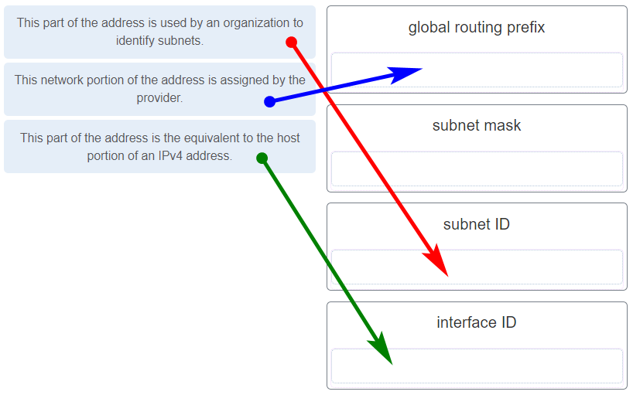

**133. Refer to the exhibit. If Host1 were to transfer a file to the server, what layers of the TCP/IP model would be used?**

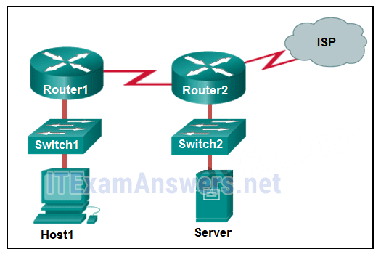

* only application and Internet layers
* only Internet and network access layers
* only application, Internet, and network access layers
* **application, transport, Internet, and network access layers**
* only application, transport, network, data link, and physical layers
* application, session, transport, network, data link, and physical layers

**Explanation:** The TCP/IP model contains the application, transport, internet, and network access layers. A file transfer uses the FTP application layer protocol. The data would move from the application layer through all of the layers of the model and across the network to the file server.

**134. Match the characteristic to the forwarding method. (Not all options are used.)**

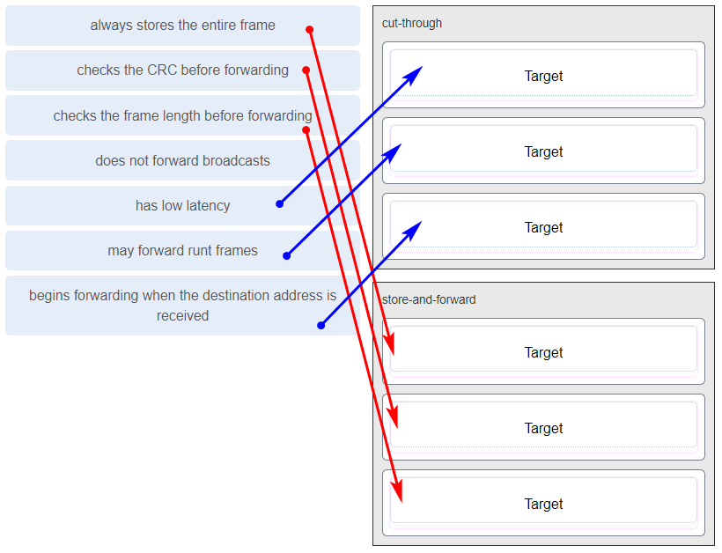

**Explanation:** A store-and-forward switch always stores the entire frame before forwarding, and checks its CRC and frame length. A cut-through switch can forward frames before receiving the destination address field, thus presenting less latency than a store-and-forward switch. Because the frame can begin to be forwarded before it is completely received, the switch may transmit a corrupt or runt frame. All forwarding methods require a Layer 2 switch to forward broadcast frames.

**135. Refer to the exhibit. The IP address of which device interface should be used as the default gateway setting of host H1?**  
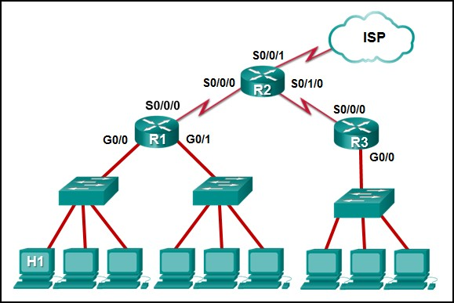

* R1: S0/0/0
* R2: S0/0/1
* **R1: G0/0**
* R2: S0/0/0

**136. What service is provided by Internet Messenger?**

* **An application that allows real-time chatting among remote users.**
* Allows remote access to network devices and servers.
* Resolves domain names, such as cisco.com, into IP addresses.
* Uses encryption to provide secure remote access to network devices and servers.

**137. Refer to the exhibit. Match the network with the correct IP address and prefix that will satisfy the usable host addressing requirements for each network.**

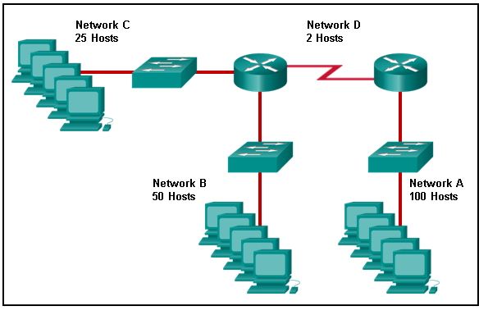

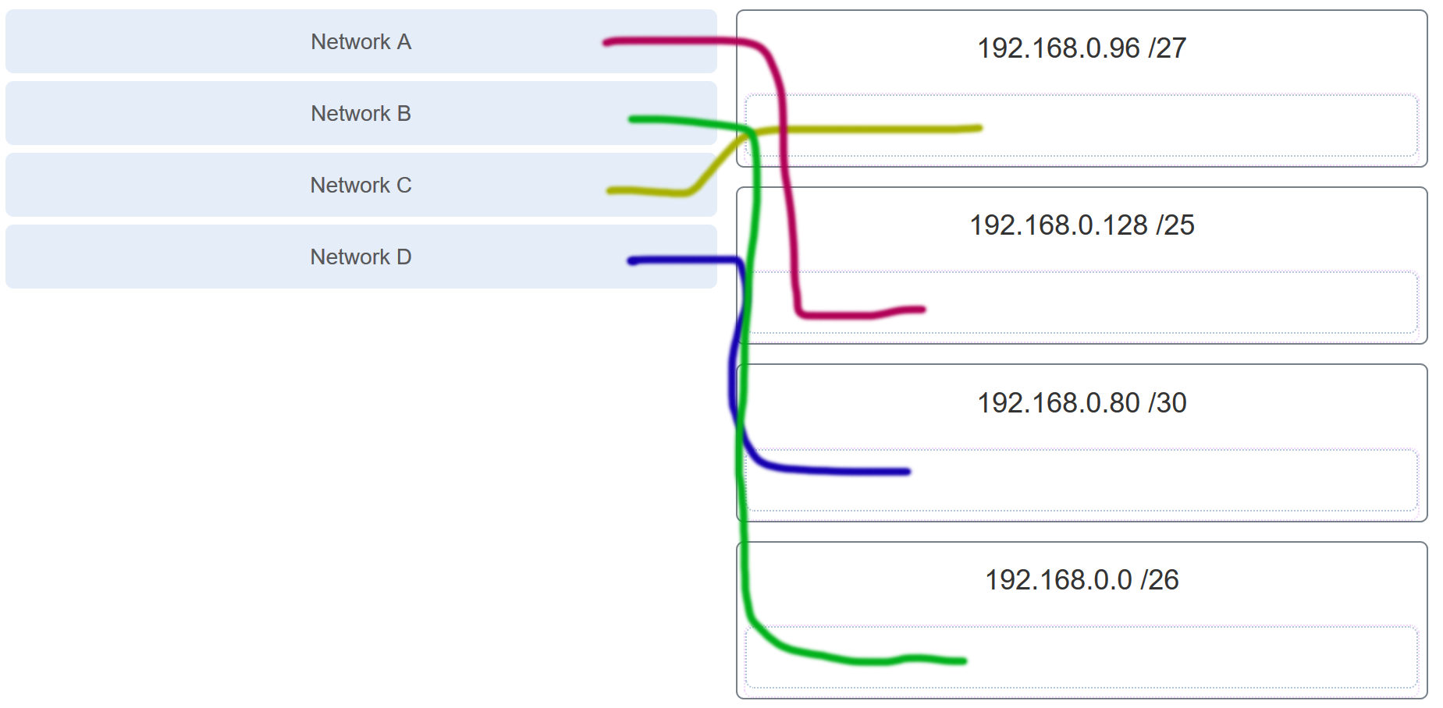

**Explanation:** Network A needs to use 192.168.0.128 /25, which yields 128 host addresses.  
Network B needs to use 192.168.0.0 /26, which yields 64 host addresses.  
Network C needs to use 192.168.0.96 /27, which yields 32 host addresses.  
Network D needs to use 192.168.0.80/30, which yields 4 host addresses.

**138. Refer to the exhibit. Which protocol was responsible for building the table that is shown?**

interface: 192.168.1.67 — 0xa

internet address physical address type

192.168.1.254 64-0f-29-0d-36-91 dynamic

.

.

.

interface: 10.82.253.91 —- 0x10

* DHCP
* **ARP**
* DNS
* ICMP

**139. A network administrator notices that some newly installed Ethernet cabling is carrying corrupt and distorted data signals. The new cabling was installed in the ceiling close to fluorescent lights and electrical equipment. Which two factors may interfere with the copper cabling and result in signal distortion and data corruption? (Choose two.)**

* crosstalk
* extended length of cabling
* **RFI**​
* **EMI**
* signal attenuation

**140. A host is trying to send a packet to a device on a remote LAN segment, but there are currently no mappings in its ARP cache. How will the device obtain a destination MAC address?**

* It will send the frame and use its own MAC address as the destination.
* It will send an ARP request for the MAC address of the destination device.
* It will send the frame with a broadcast MAC address.
* It will send a request to the DNS server for the destination MAC address.
* **It will send an ARP request for the MAC address of the default gateway.**

**141. Which two functions are performed at the MAC sublayer of the OSI Data Link Layer to facilitate Ethernet communication?**

* **integrates Layer 2 flows between 10 Gigabit Ethernet over fiber and 1 Gigabit Ethernet over copper**
* enables IPv4 and IPv6 to utilize the same physical medium
* handles communication between upper layer networking software and Ethernet NIC hardware
* adds Ethernet control information to network protocol data
* **implements CSMA/CD over legacy shared half-duplex media**

**142. A client packet is received by a server. The packet has a destination port number of 53. What service is the client requesting?**

* **DNS**
* NetBIOS (NetBT)
* POP3
* IMAP

**143. A network administrator is adding a new LAN to a branch office. The new LAN must support 25 connected devices. What is the smallest network mask that the network administrator can use for the new network?**

* 255.255.255.128
* 255.255.255.192
* **255.255.255.224**
* 255.255.255.240

**144. What characteristic describes a Trojan horse?**

* **malicious software or code running on an end device**
* an attack that slows or crashes a device or network service
* the use of stolen credentials to access private data
* a network device that filters access and traffic coming into a network

**145. What service is provided by HTTPS?**

* Uses encryption to provide secure remote access to network devices and servers.
* Resolves domain names, such as cisco.com, into IP addresses.
* **Uses encryption to secure the exchange of text, graphic images, sound, and video on the web.**
* Allows remote access to network devices and servers.

**146. A technician with a PC is using multiple applications while connected to the Internet. How is the PC able to keep track of the data flow between multiple application sessions and have each application receive the correct packet flows?**

* The data flow is being tracked based on the destination MAC address of the technician PC.
* **The data flow is being tracked based on the source port number that is used by each application.\***
* The data flow is being tracked based on the source IP address that is used by the PC of the technician.
* The data flow is being tracked based on the destination IP address that is used by the PC of the technician.

**Explanation:**  
The source port number of an application is randomly generated and used to individually keep track of each session connecting out to the Internet. Each application will use a unique source port number to provide simultaneous communication from multiple applications through the Internet.

**147. A network administrator is adding a new LAN to a branch office. The new LAN must support 61 connected devices. What is the smallest network mask that the network administrator can use for the new network?**

* 255.255.255.240
* 255.255.255.224
* **255.255.255.192**
* 255.255.255.128

**148. Refer to the exhibit. Match the network with the correct IP address and prefix that will satisfy the usable host addressing requirements for each network. (Not all options are used.)**  
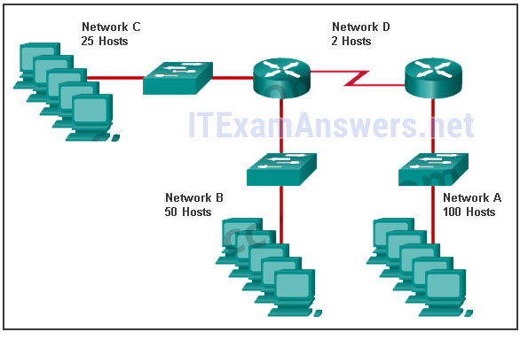  
**Question**  
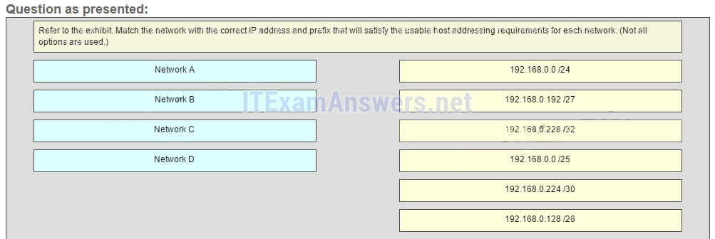  
**Answer**  
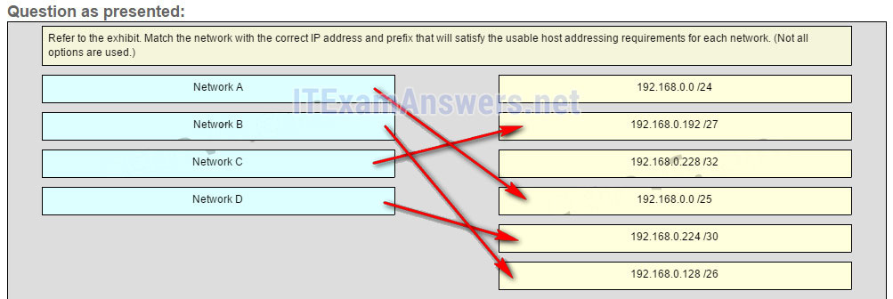

**Explanation:**  
Network A needs to use 192.168.0.0 /25 which yields 128 host addresses.  
Network B needs to use 192.168.0.128 /26 which yields 64 host addresses.  
Network C needs to use 192.168.0.192 /27 which yields 32 host addresses.  
Network D needs to use 192.168.0.224 /30 which yields 4 host addresses.

**149. What characteristic describes a DoS attack?**

* the use of stolen credentials to access private data
* a network device that filters access and traffic coming into a network
* software that is installed on a user device and collects information about the user
* **an attack that slows or crashes a device or network service**

**150. Match the application protocols to the correct transport protocols**  
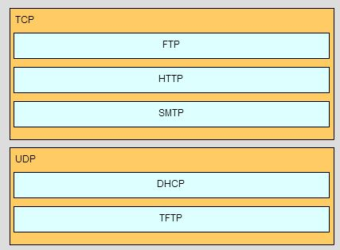

**151. What service is provided by SMTP?**

* **Allows clients to send email to a mail server and the servers to send email to other servers.**
* Allows remote access to network devices and servers.
* Uses encryption to provide secure remote access to network devices and servers.
* An application that allows real-time chatting among remote users.

**152. Match a statement to the related network model. (Not all options are used.)**  
  
  
**Place the options in the following order:peer-to-peer network**  
**[+] no dedicated server is required**  
**[+] client and server roles are set on a per request basis**  
**peer-to-peer aplication**  
**[#] requires a specific user interface**  
**[#] a background service is required**

**Explain:**  
Peer-to-peer networks do not require the use of a dedicated server, and devices can assume both client and server roles simultaneously on a per request basis. Because they do not require formalized accounts or permissions, they are best used in limited situations. Peer-to-peer applications require a user interface and background service to be running, and can be used in more diverse situations.

**153. Match the application protocols to the correct transport protocols.**

* Question  
  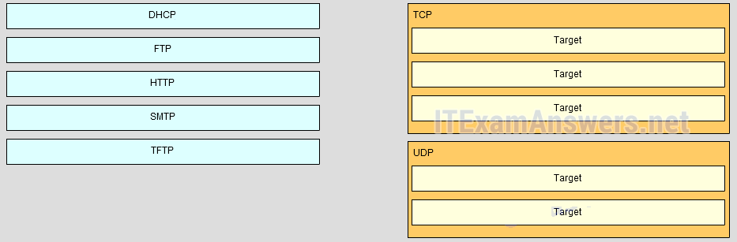
* Answer  
  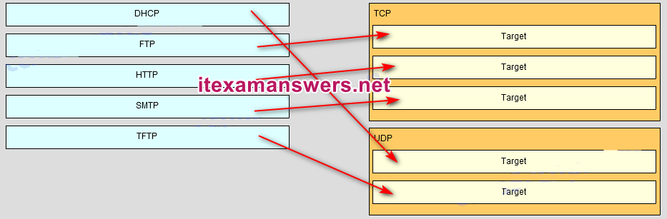

**154. Refer to the exhibit. A network engineer has been given the network address of 192.168.99.0 and a subnet mask of 255.255.255.192 to subnet across the four networks shown. How many total host addresses are unused across all four subnets?**  
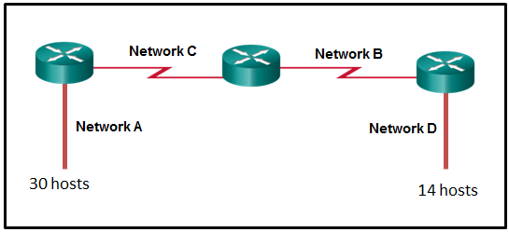

* 88
* **200**
* 72
* 224
* 158

**155. Which two functions are performed at the MAC sublayer of the OSI Data Link Layer to facilitate Ethernet communication? (Choose two.)**

* **places information in the Ethernet frame that identifies which network layer protocol is being encapsulated by the frame**
* handles communication between upper layer networking software and Ethernet NIC hardware
* adds Ethernet control information to network protocol data
* **applies source and destination MAC addresses to Ethernet frame**
* applies delimiting of Ethernet frame fields to synchronize communication between nodes

**156. Which connector is used with twisted-pair cabling in an Ethernet LAN?**

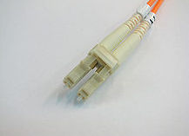

LC conector

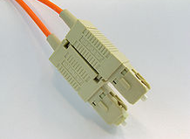

SC conector

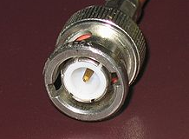

BNC

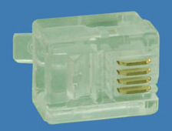

RJ 11

**True Answer:**

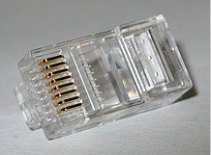

RJ 45 (true answer)

**157. A client packet is received by a server. The packet has a destination port number of 22. What service is the client requesting?**

* + **SSH**
  + SMB/CIFS
  + HTTPS
  + SLP

**158. What characteristic describes an IPS?**

* + - a tunneling protocol that provides remote users with secure access into the network of an organization
    - a network device that filters access and traffic coming into a network
    - **software that identifies fast-spreading threats**
    - software on a router that filters traffic based on IP addresses or applications

**159. What service is provided by DHCP?**

* + - An application that allows real-time chatting among remote users.
    - Allows remote access to network devices and servers.
    - **Dynamically assigns IP addresses to end and intermediary devices.**
    - Uses encryption to provide secure remote access to network devices and servers.

**160. Which two functions are performed at the LLC sublayer of the OSI Data Link Layer to facilitate Ethernet communication? (Choose two.)**

* + - responsible for internal structure of Ethernet frame
    - applies source and destination MAC addresses to Ethernet frame
    - integrates Layer 2 flows between 10 Gigabit Ethernet over fiber and 1 Gigabit Ethernet over copper
    - **enables IPv4 and IPv6 to utilize the same physical medium**
    - **handles communication between upper layer networking software and Ethernet NIC hardware**

**161. Which two functions are performed at the LLC sublayer of the OSI Data Link Layer to facilitate Ethernet communication? (Choose two.)**

* + - **adds Ethernet control information to network protocol data**
    - responsible for internal structure of Ethernet frame
    - implements trailer with frame check sequence for error detection
    - **enables IPv4 and IPv6 to utilize the same physical medium**
    - applies source and destination MAC addresses to Ethernet frame

**162. Which two functions are performed at the MAC sublayer of the OSI Data Link Layer to facilitate Ethernet communication? (Choose two.)**

* + - **implements CSMA/CD over legacy shared half-duplex media**
    - enables IPv4 and IPv6 to utilize the same physical medium
    - adds Ethernet control information to network protocol data
    - handles communication between upper layer networking software and Ethernet NIC hardware
    - **integrates Layer 2 flows between 10 Gigabit Ethernet over fiber and 1 Gigabit Ethernet over copper**

**163. Which two functions are performed at the MAC sublayer of the OSI Data Link Layer to facilitate Ethernet communication? (Choose two.)**

* + **places information in the Ethernet frame that identifies which network layer protocol is being encapsulated by the frame**
  + handles communication between upper layer networking software and Ethernet NIC hardware
  + adds Ethernet control information to network protocol data
  + **applies source and destination MAC addresses to Ethernet frame**
  + applies delimiting of Ethernet frame fields to synchronize communication between nodes